Worksheet 1 – Skeleton and Bones
This worksheet covers:
- Classification of bones
- The structure of a long bone
- Structures of the axial and appendicular skeleton
- Name and locations of bones.
- Posture and curves of the spine
- Basic functions of the skeleton
- The stages of bone growth
- Posture and curves of the spine
- Effects of exercise on the bones

Name and describe the different classifications or types of bones.
Name | Description

Name the type or classification of bone pictured.
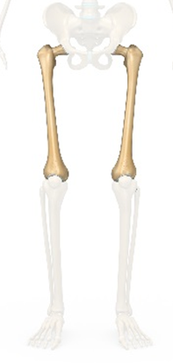
Name the type or classification of bone pictured.
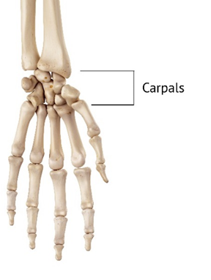
Name the type or classification of bone pictured.

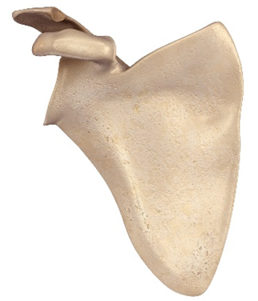
Name the type or classification of bone pictured.
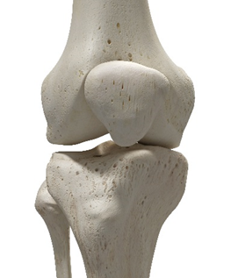

Extension task: Use the diagram to colour in examples of the different classifications of bones.
- Long
- Short
- Flat
- Irregular
- Sesamoid
