Shrewsbury College L3 Extended Diploma Fashion & Textiles
SUMMER HOMEWORK FOR NEW STUDENTS
Upcycling Unit: Understand the effect of recycling and sustainability on the fashion industry.
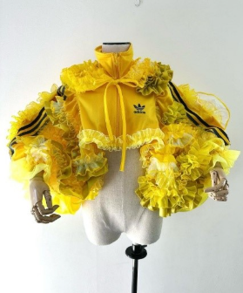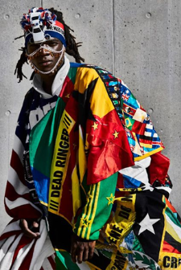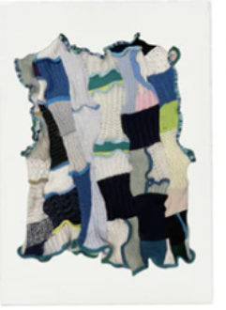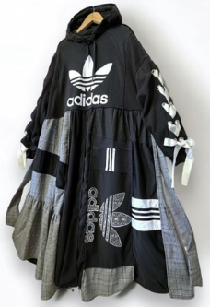

TASK 1: INVESTIGATE
2xA3 pages
Create a mind map on upcycling, re-cycling, and sustainability within the fashion industry. This should include images and definitions to demonstrate your own understanding of the wider topic. Try to find designers who work with upcycled and reclaimed materials and make a note of their name.
KEY WORDS: reclaimed materials / ecological sustainability / vintage and retro/preloved clothes / eco fashion / fast fashion

TASK 2: INSPIRATION
1x A3 page
Collect and collate 1x A3 page of images that you find inspiring on the theme reassembled sports. Consider upcycled sportswear and other upcycled garments, looking at different types of designers and styles. Aim for about 10-20 images.

TASK 3: COLLECT
3+ garments to upcycle in class
Over summer collect three or more pieces of sportswear to use in the upcycling project starting in September. Consider old school sports kits, football or rugby strips, dance and gymnastics wear, technical fabrics, and anything else you can think of!

