Early Years and Education Department Induction



Introduction to the Early Years and Education Department

Name: _________________________________

What will I be studying?
- Level 1
The course is career related and is open to students who wish to:
- Obtain employment as assistants in Health & Social Care or Early Years settings
- Progress to Level 2
- Develop Social Skills, Caring Skills and an understanding of Early Years
- Gain a positive learning experience with like-minded fellow students.

- Level 2 Certificate in Supported Teaching and Learning
This course is career related and is open to students who wish to be working as or progress to a Teaching Assistant; Learning Support Assistant; Special Educational; Needs Assistant or related roles.
The course consists of 11 units that cover a wide range of areas including:
• Children and young people’s development
• Supporting children’s learning
• Young people’s positive behaviour and communication
• Professional relationships
You'll be required to complete hours in placement to be able to demonstrate skills and competency.
- T Level Foundation in Early Years
The T Level Foundation Programme provides a high-quality route onto T Levels for students who would benefit from the additional study time and preparation that it will give them before they start their T Level. Our T Level Foundation Programme, giving a licence to practice, and is a one-year course designed to develop the skills, knowledge and behaviours to support progression.
You will spend three days a week in college and two days a week on placement in a local early years setting. You'll be required to complete 250 hours in placement to be able to demonstrate skills and competency.
- T Level in Early Years and Education: Early Years Educator
- T Level in Early Years: Assisted Teaching
These are two-year technical study programmes, designed with employers to give young people the skills that the childcare and education sector needs.
You will spend 3 days a week in college and 2 days in either a local school (Reception class) or early years setting, and complete 750 placement hours over 2 years.
Students will be assessed via the core components of: Paper A written examination, Paper B written examination, Employer-set project, Occupational specialism component through a series of synoptic assignments and assessments.
All of our courses cover safeguarding and welfare issues, which you may find upsetting. However, you can speak to staff and we can support you as needed.


Recommended watching for Early Years and Education
Please choose 3 of the below programmes and write an outline of what you have learnt from watching on the page below…
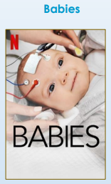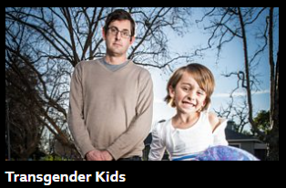
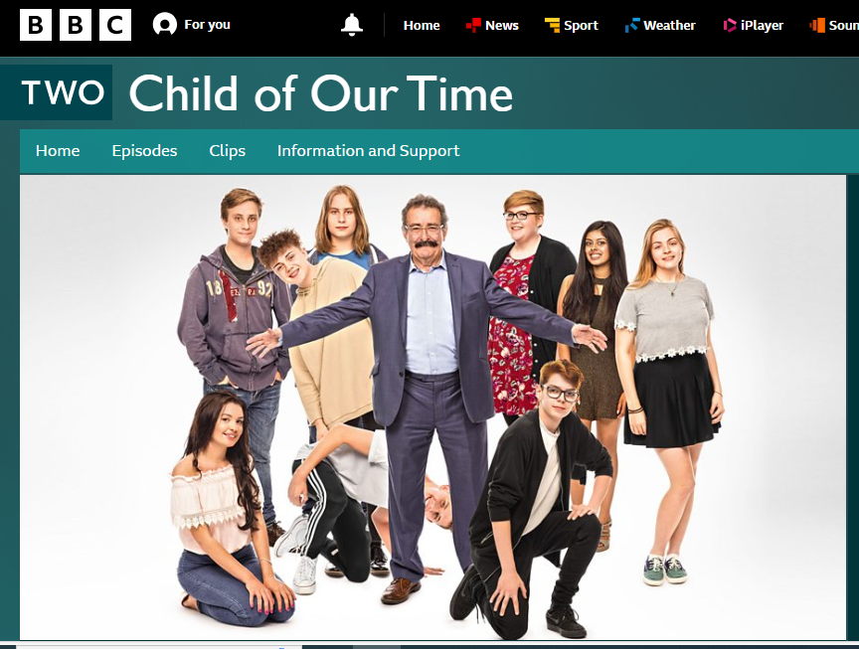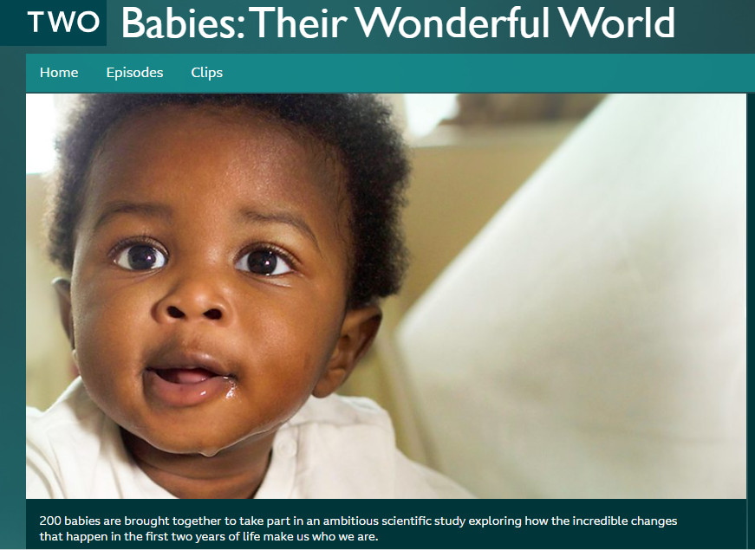

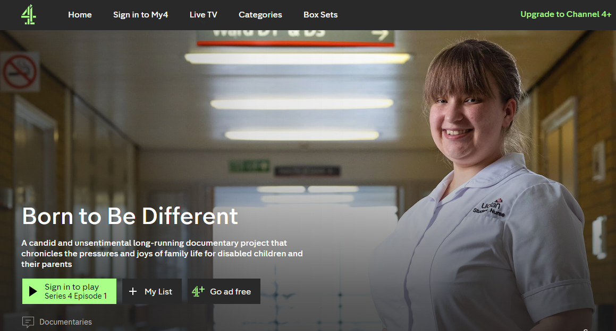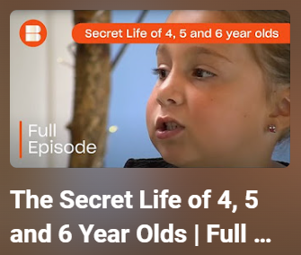
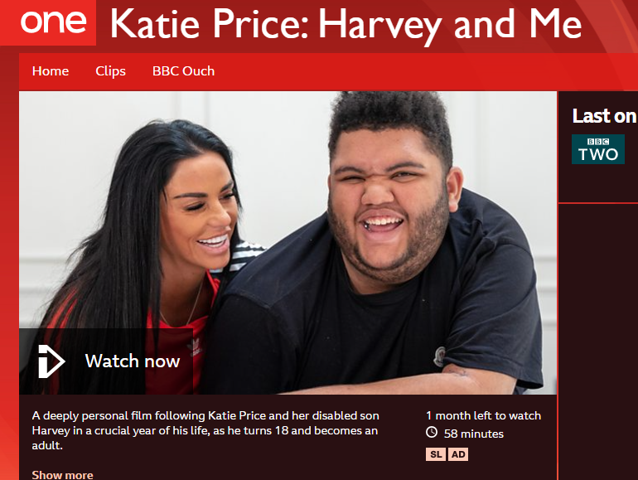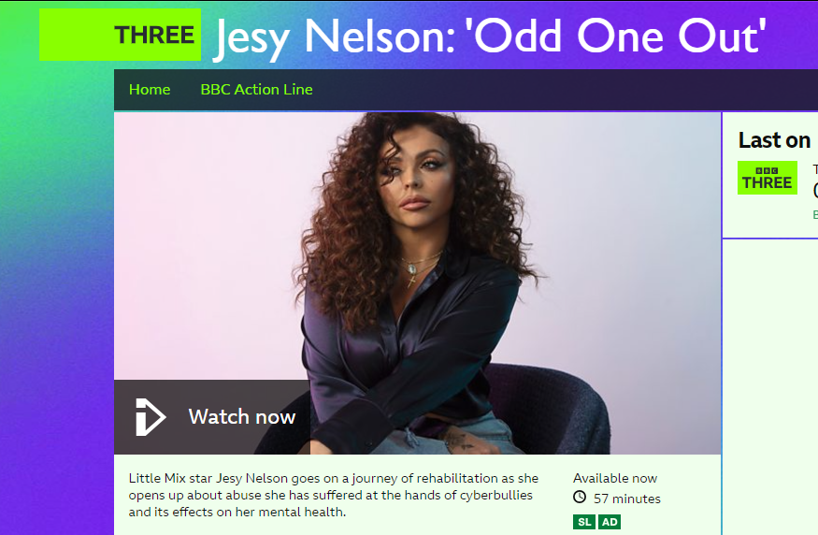
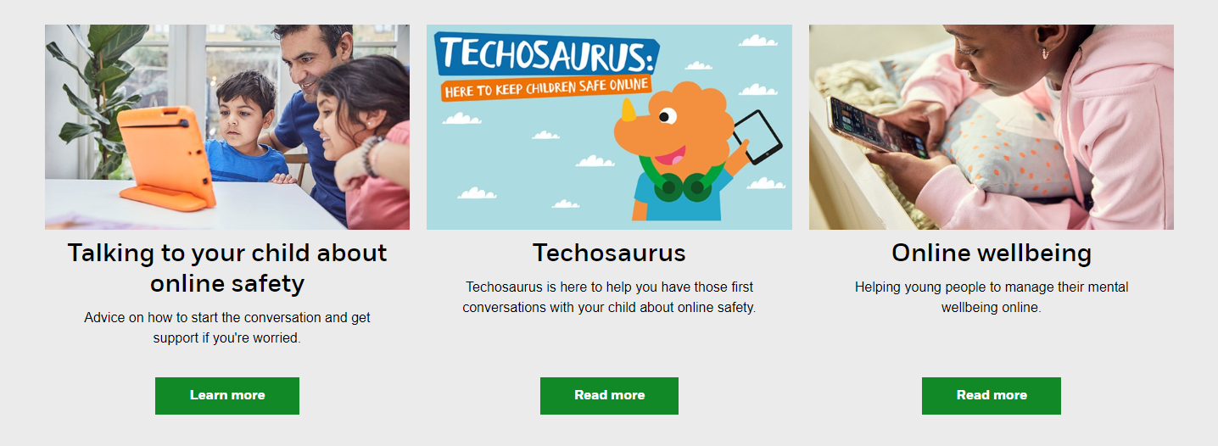

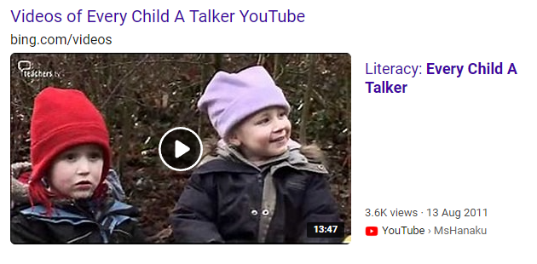“Every Child a Talker”

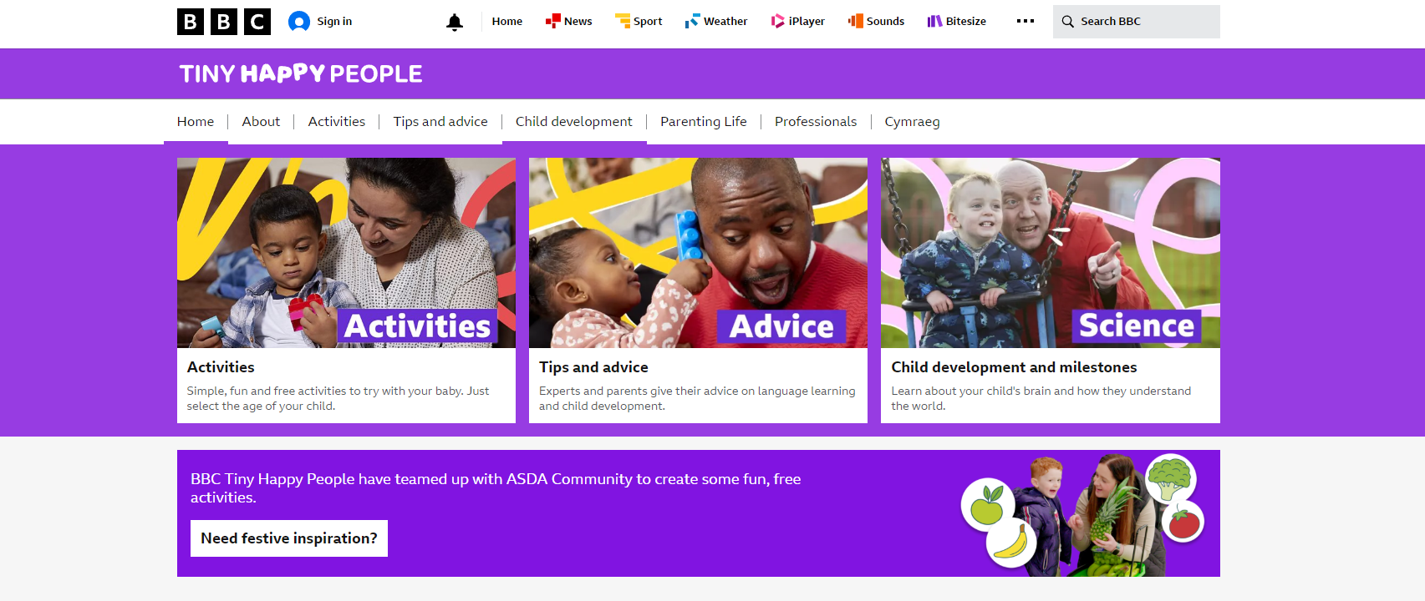
- Programme watched:
What I have learnt from watching this programme:
- Programme watched:
What I have learnt from watching this programme:

- Programme watched:
What I have learnt from watching this programme:

Recommended reading for Early Years and Education
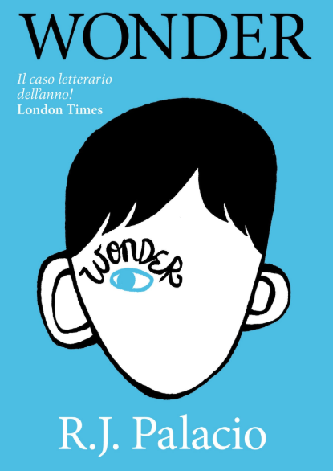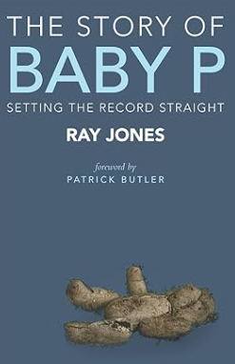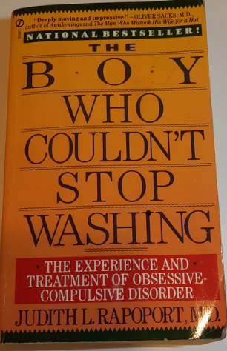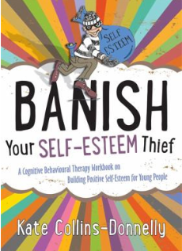

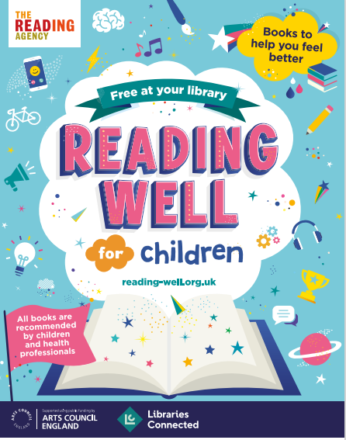
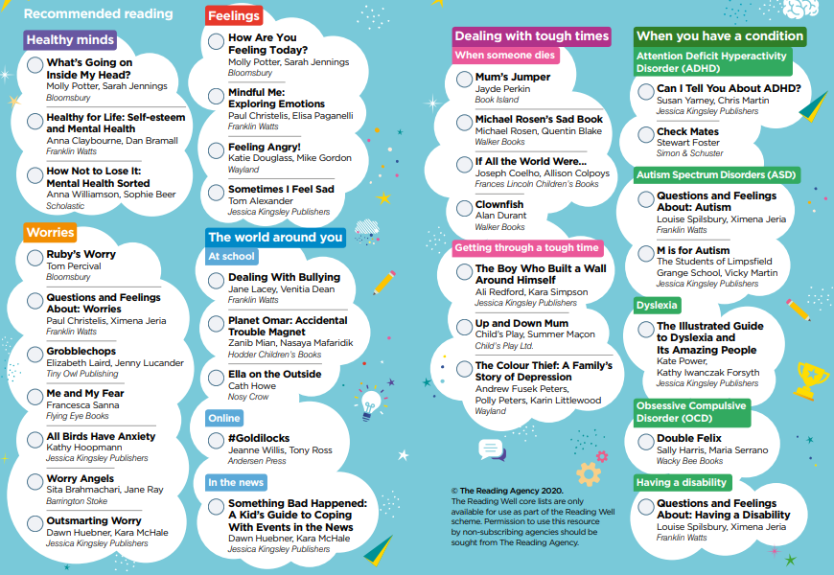
Early Years and Education
in the Media

One way of raising your awareness, before your course starts, is to look at different forms of media about Early Years and Education.

Examples:
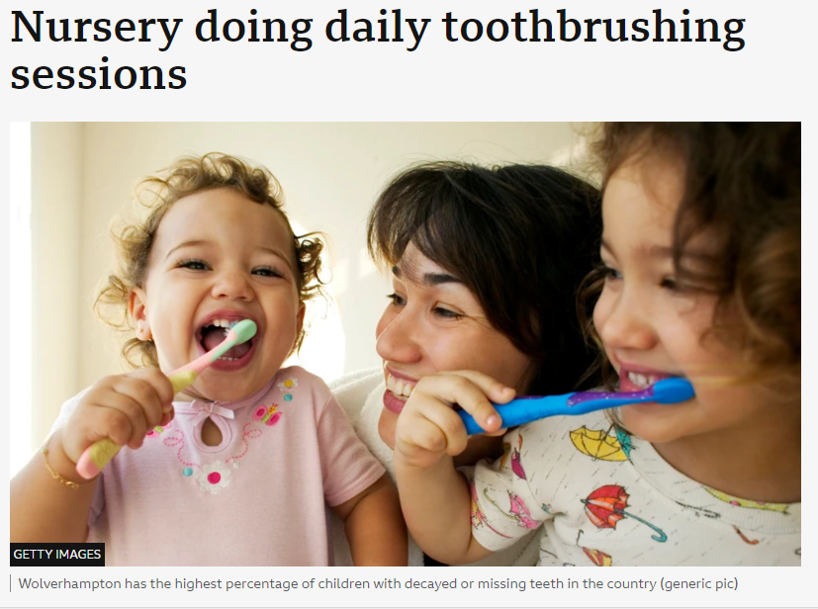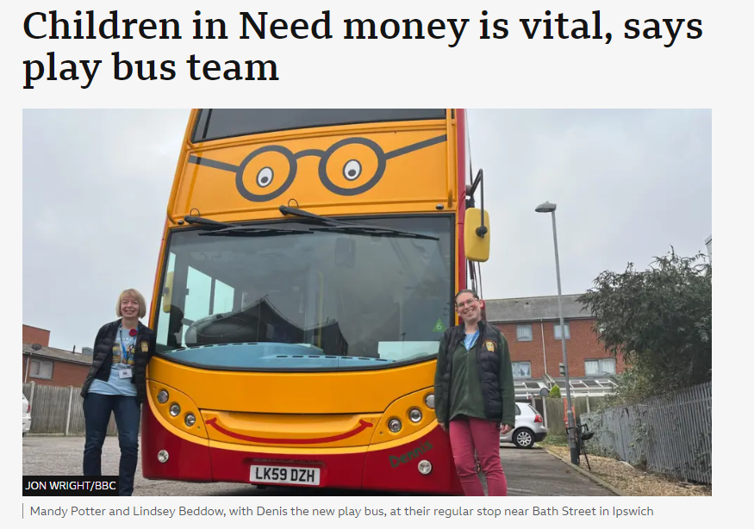
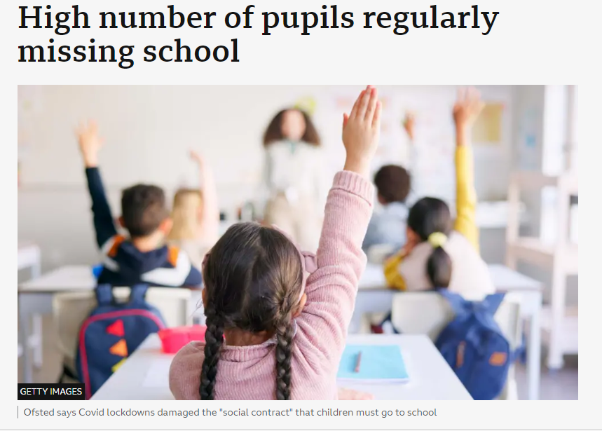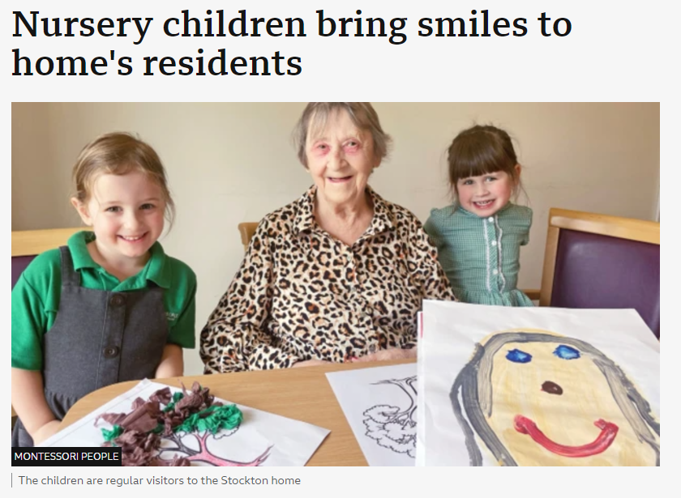

Your task:
Find a news article about:
Early years, Children, Schools or other Educational Settings and write about what you found out below
(Include the headline, date, website or newspaper it came from…)

Glossary
Task: Research and define the following words.
They are words you will need to use correctly. In the end column, summarise the term visually to help you remember it.
Term | Definition
Child
Development
Safeguarding
Respect
Education
Play
Behaviour
Discrimination
Inclusion
Learning
Gender
Holistic
Interaction
Milestones
Policy
Role model
Transition

Early Years and Education
RESEARCH TASK!

Choose a professional from the list below:
(You could choose your own idea from an Early Years & Education professional role if you’d prefer)

- Nursery Practitioner / Early Years Educator
- Teaching Assistant
- Primary School Teacher
- Special Educational Needs Coordinator
- Speech and Language Therapist
- Social Worker
- Children’s Nurse
- Nanny

Write a report (no more than an A4 sheet) explaining:
- Why you chose this professional?
- What their role involves?
- The impact they have on children and/or education…

We look forward to welcoming you on your chosen course!

This induction booklet is important for your progression onto the course and shows us your interests and why you have chosen this as your next step.

You can get in touch with us if you have any questions:
admissions@shrewsbury.ac.uk or info@shrewsbury.ac.uk

College reception: 01743 653000

