
- To order, scan the QR code or visit www.capitalhairandbeauty.co.uk/student-ordering
- Create a new account
- When prompted, enter your College/Student club code shown below
- Find your correct kit and follow the checkout instructions
Order Here Please place your order as early as possible and allow up to 14 days for delivery
College Code/Student Club Code |  | C35602
College Name | Shrewsbury College | Kit Price | £14.67
Kit Name | Beauty Holistic 2026 | Delivery Method | HOME DELIVERY INCLUDED

Qty Description
1.00 Headband Black
2.00 Mask Sponge (Pk 2)
1.00 Plastic Spatula 15Cm
1.00 Stiring Rod
1.00 Towelling Turban
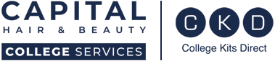
1.00 Measuring Cup 60Ml
College Kits Direct, Unit 24 Ashville Way, Whetstone, LE8 6NU
Email: info@collegekitsdirect.com Tel: 0116 2847022

For full T&Cs please visit www.collegekitsdirect.com/terms-conditions/

