A-Level & Cambridge Technicals Textbooks for Year 1 Students
Subject | Book Image | Title & Author | ISBN | Comments
Applied Science |  | Cambridge Advanced Nationals (AAQ) Applied Science F180-F182 Course Companion  By Bunker, D, de Villiers, E, Georgiev, I, Jones, D, Miles, C, Smyth, M, Lawrence, Rachel | 9781909801066 | Available as Timed Loan and One Week Loan from the LRCs, as well as Classroom only copies.
Biology | 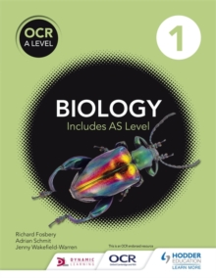 | OCR A level biology Year 1 student book  By: Fosbery, Richard, Schmit, Adrian, Wakefield-Warren, Jenny | 9781471809156 | Issued as textbook loan through College for first year.  Available as an e-Book on Biology Year 1 Moodle page  Also available as Timed Loan.
Biology | 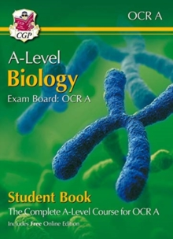 | A-Level Biology for OCR A: Year 1 & 2 Student Book with Online Edition  By: CGP Books | 9781789086676 | Available to purchase through College.  Also available as Timed Loan and One Week Loan

Subject | Book Image | Title & Author | ISBN | Comments
Biology | 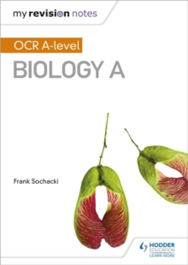 | My Revision Notes – OCR Biology A-Level  Part of the My Revision Notes series | 9781471842269 | Available as Timed Loan and One Week Loan
Biology | 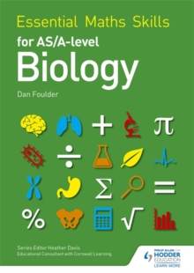 | Essential maths skills for AS/A level biology  By: Foulder, Dan | 9781471863455 | Available as an e-Book, as Timed Loan and One Week Loan in the LRCs
Business | 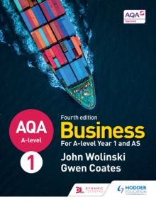 | AQA business for A level 1  John Wolinski & Gwen Coates | 9781510454958 | Available as an e-Book in College, and as Timed Loan in the LRCs
Subject | Book Image | Title & Author | ISBN | Comments
Business | 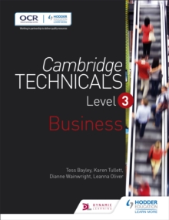 | Cambridge Technicals Level 3 Business | 9781471874796 | Available as an e-Book in College, and as Timed Loan in the LRCs
Business | 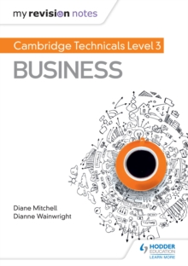 | Cambridge Technicals Level 3 Business  Wainwright, Dianne  Part of the My Revision Notes series |  | Available as an e-Book in College, and as Timed Loan in the LRCs
Chemistry | 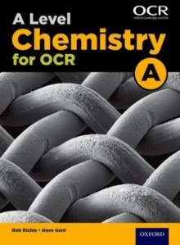 | A level chemistry A for OCR  By Dave Gent & Rob Ritchie | 9780198351979 | Available as an e-Book in College via Kerboodle.  Also available as Timed Loan and One Week Loan in the LRCs.
Subject | Book Image | Title & Author | ISBN | Comments
Chemistry | 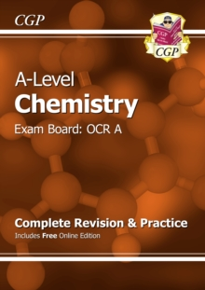 | OCR A-Level Chemistry Complete Revision & Practice  By Katie Braid  CGP Books | 9781782943020 | Available as one week loan and Timed Loan in Quarry LRC
Classical Civilisation |  | The Aeneid  By: Virgil, West, David(Introduction by), West, David(Translated by)  Part of the Penguin classics series | 9780140449327 | Available in College as textbook loan and in classrooms
Classical Civilisation | 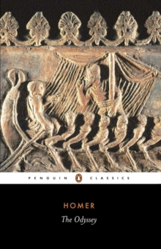 | The Odyssey (Rev [ed.])  By: Homer, Jones, Peter(Introduction by), Rieu, Dominic(Revised by), Rieu, E. V.(Translated by)  Part of the Penguin classics series | 9780140449112 | Available in College as textbook loan and in classrooms
Subject | Book Image | Title & Author | ISBN | Comments
Classical Civilisation | 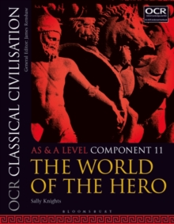 | OCR classical civilisation AS and A level component 11: The world of the hero  By: Knights, Sally | 9781350015074 | Available in College on Timed Loan and in classrooms
Classical Civilisation | 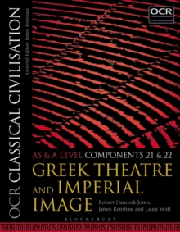 | OCR classical civilisation AS and A level components 21 and 22: Greek theatre and Imperial image  By: Hancock-Jones, Robert and Renshaw, James | 9781350015111 | Available in College as Timed Loan and as an e-Book in College, and in classrooms
Classical Civilisation | 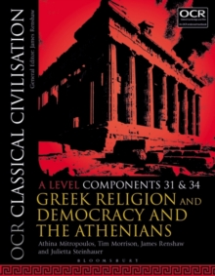 | OCR classical civilisation A level components 31 and 34,: Greek religion and democracy and the Athenians  By: Mitropoulos, Athina and Renshaw, James | 9781350020993 | Available in College as Timed Loan and as an e-Book plus in classrooms
Subject | Book Image | Title & Author | ISBN | Comments
Drama & Performance |  | Company | 9781848428355 | Play will be available to purchase through College
Drama & Performance |  | Small Island | 9781848428515 | Play will be available to purchase through College, but reading the novel beforehand will definitely help.
Economics | 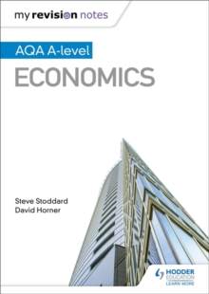 | Hodder Education  Economics A-Level Revision Guide | 9781471865879 | Available to borrow on Timed Loan and on One Week Loan through LRCs at College.  Also available to purchase through College
Subject |  | Book Image | Title & Author |  | ISBN |  |  | Comments
English Language |  | 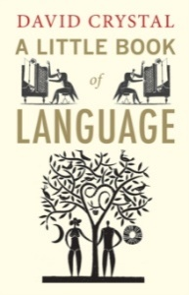 | A Little Book of Language by David Crystal |  | 9780300170825 |  |  | Available as three week loan in LRC
English Combined  &  English Literature |  |  | A Handmaid’s Tale by Margaret Atwood |  | 9780099740919  9780330516778 |  |  | Available to purchase through College
English Literature |  |  | 1984 by George Orwell |  | 9781849432269 |  |  | Available to purchase through College
Subject |  | Book Image | Title & Author |  | ISBN |  |  | Comments
Geography |  | 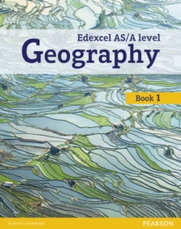 | Edexcel AS/A Level Geography Book 1  By Lindsay Frost  Pearson Ltd |  | 9781292139623 |  |  | Available to purchase through College and also on One Week Loan and Timed Loan in the LRCs
Geography |  | 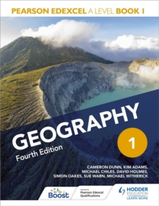 | Geography 1 (Fourth edition) - Hodder  By: Adams, Kim, Chiles, Michael, Dunn, Cameron, Holmes, David, Oakes, Simon, Warn, Sue, Witherick, Michael |  | 978139831255 |  |  | Available to purchase through College and also on One Week Loan and Timed Loan in the LRCs  Available as an e-Book in College
Geography |  | 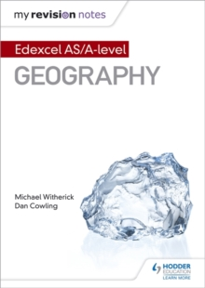 | My Revision Notes Edexcel S/A Level Geography  By Michael Witherick  Hodder Education  Part of the My Revision Notes series |  | 9781471886744 |  |  | Available on One Week Loan and Timed Loan in the LRCs. Available as an e-Book in College.
Subject | Book Image |  |  | Title & Author |  | ISBN | Comments
Geology | 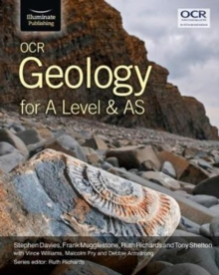 |  |  | OCR Geology for A Level & AS  By Stephen Davies  Illuminate Publishing |  | 9781911208143 | Available on Timed Loan in both LRCs  New exam board is Eduqas but this is still the textbook to use.
Health & Social Care | 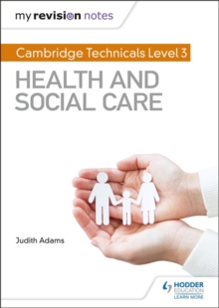 |  |  | Cambridge Technicals level 3 health and social care  By: Adams, Judith  Part of the My Revision Notes series |  | 9781510442306 | Available in Classrooms and online as an e-Book on Moodle and Teams
Health & Social Care | 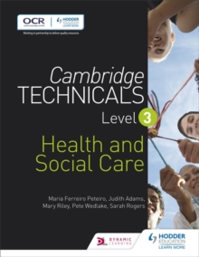 |  |  | Cambridge Technicals Level 3 Health and social care  By: Adams, Judith, Peteiro, Maria Ferreiro, Riley, Mary, Rogers, Sarah, Wedlake, Pete |  | 9781471874765 | Available in Classrooms and online as an e-Book on Moodle and Teams
Subject | Book Image |  |  | Title & Author |  | ISBN | Comments
Health & Social Care | 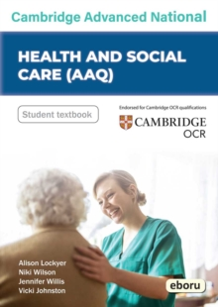 |  |  | Cambridge Advanced National Health & Social Care (AAQ) |  | 9780992900298 | Available as Timed Loan and One Week Loans in College and as classroom copies.
History | 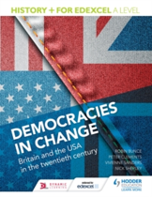 |  |  | Democracies in Change History+ for Edexcel A level: Democracies in change : Britain and the USA in the twentieth century By: Bunce, Robin, Clements, Peter, Sanders, Vivienne, Shepley, Nick |  | 9781471837685 | Available as an e-Book in College  and to borrow as Timed Loan or three week loans
ICT | 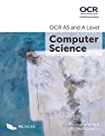 |  |  | OCR AS and A Level Computer Science  By P.M. and R. Heathcote |  | 9781910523056 | Available as One Week Loan and Timed Loan in the LRCs
Subject | Book Image |  |  | Title & Author |  | ISBN | Comments
Law | 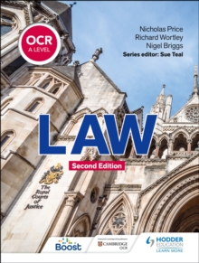 |  |  | OCR A-level Law 2nd edition  By: Price, Nicholas & Wortley, Richard |  | 9781398326477 | Available as Timed Loan and One Week Loan from the LRCs, as well as Classroom only copies.
Mathematics | 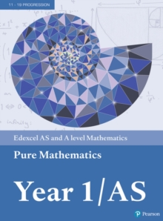 |  |  | Edexcel Pure Maths Year 1/AS  Edited by  Harry Smith  Pearson Ltd |  | 9781292183398 | Available as textbook loans and as Timed Loan from LRCs on both Bridges Campuses
Mathematics | 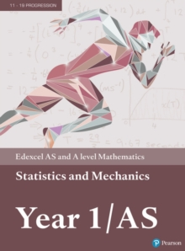 |  |  | Edexcel Statistics & Mechanics Maths Year 1/AS  Edited by  Harry Smith  Pearson Ltd |  | 9781292232539 | Available as textbook loans and as Timed Loan from LRCs on both Bridges Campuses
Subject | Book Image |  |  | Title & Author |  | ISBN | Comments
Further Mathematics | 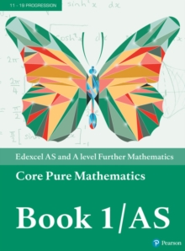 |  |  | Edexcel AS/A Level Further Mathematics Core Pure Book 1  Edited by Harry Smith  Pearson Ltd |  | 9781292183336 | Available as textbook loans and as Timed Loan from LRCs on both Bridges Campuses
Further Mathematics | 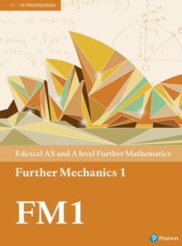 |  |  | Edexcel AS/A Level Further Mathematics Further Mechanics1  Edited by Harry Smith  Pearson Ltd |  | 9781292183312 | Available as textbook loans and as Timed Loan from LRCs on both Bridges Campuses
Further Mathematics | 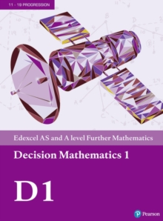 |  |  | Edexcel AS/A Level Further Mathematics Decision 1  Edited by Harry Smith  Pearson Ltd |  | 9781292183299 | Available as textbook loans and as Timed Loan from LRCs on both Bridges Campuses
Subject | Book Image |  |  | Title & Author |  | ISBN | Comments
Media Studies | 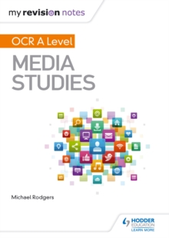 |  |  | OCR A level media studies  Rodgers, Michael  Part of the My Revision Notes series |  | 9781510429215 | Available as an e-Book online in College, and as a three week loan in the LRCs
Modern Foreign Languages | 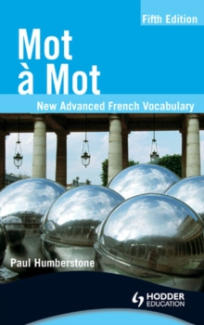 |  |  | Mot a Mot French vocabulary |  | 9781510434806 | Available as an e-Book online in College, and as a three week loan in the LRCs
Modern Foreign Languages | 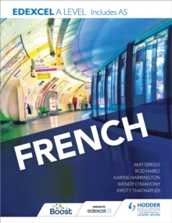 |  |  | Edexcel A-Level French textbook |  | 9781471858161 | Available as Classroom only copy, Timed Loan and One Week Loan in LRC
Subject | Book Image |  |  | Title & Author |  | ISBN | Comments
Modern Foreign Languages | 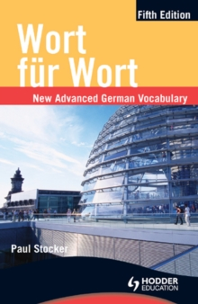 |  |  | Wort fur Wort German vocabulary |  | 9781510434844 | Available as an e-Book online in College, and as a three week loan in the LRCs
Modern Foreign Languages | 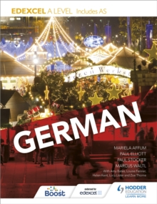 |  |  | Edexcel A-Level German textbook |  | 9781471858239 | Available as Classroom only copy, Timed Loan and One Week Loan in LRC
Modern Foreign Languages | 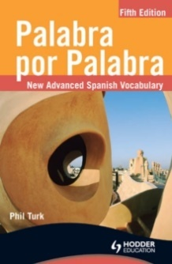 |  |  | Palabra por Palabra Spanish vocabulary |  | 9781510434820 | Available as an e-Book online in College, and as a three week loan in the LRCs
Subject | Book Image |  |  | Title & Author |  | ISBN | Comments
Physics | 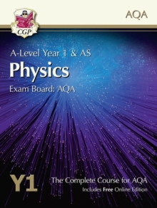 |  |  | A-Level Physics for AQA: Year 1 & AS Student Book with Online Edition  By: CGP Books |  | 9781782943235 | Issued as textbook loan through College and as Timed Loan in the LRCs
Physics | 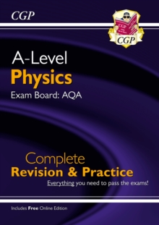 |  |  | New A-Level Physics: AQA Year 1 & 2 Complete Revision & Practice with Online Edition  By: CGP Books |  | 9781789080322 | Available to purchase through College and as One Week Loan and Timed Loan in the LRCs
Politics | 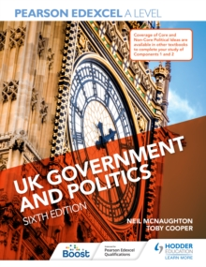 |  |  | UK Government and Politics  Neil McNaughton |  | 9781398311336 | Available as an e-Book, a One Week Loan and Timed Loan in the LRCs
Subject | Book Image |  |  | Title & Author |  | ISBN | Comments
Politics | 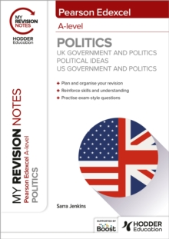 |  |  | Pearson A-Level Politics - US Politics, UK Politics and Political Ideas  Part of the My Revision Notes series |  | 9781398385047 | Available to purchase through College and as One Week Loan and Timed Loan in the LRCs
Politics | 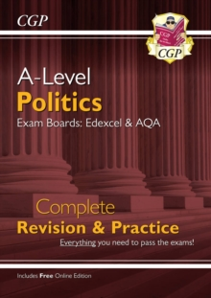 |  |  | A-Level Politics Complete Revision & Practice |  | 9781837741489 | Available to purchase through College and as One Week Loan and Timed Loan in the LRCs
Product Design | 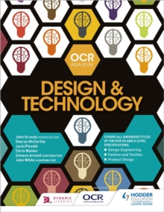 |  |  | OCR design and technology for AS/A level  By: Grundy, John, McCarthy, Sharon, Piroddi, Jacki, Walker, Chris |  | 9781510402652 | Issued as a textbook loan, available on Timed Loan and as an e-Book through College.
Subject | Book Image |  |  | Title & Author |  | ISBN | Comments
Product Design | 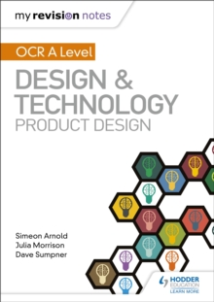 |  |  | OCR AS/A level design and technology: Product design  By:Arnold, Simeon, Morrison, Julia, Sumpner, Dave  Part of the My Revision Notes series |  | 9781510458963 | Available as an e-Book, a One Week Loan and Timed Loan in the LRCs
Product Design | 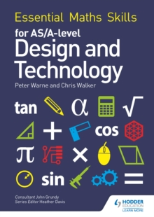 |  |  | Essential Maths Skills for AS/A Level Design and Technology  Warne, Peter |  | 9781510417052 | Available as an e-Book in College
Psychology | 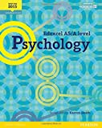 |  |  | Edexcel AS/A Level Psychology  Edited by Karren Smith  Pearson Ltd |  | 9781447982463 | Available as a One Week Loan and as a Timed Loan in the LRCs through College
Subject | Book Image |  |  | Title & Author |  | ISBN | Comments
Religious Studies | 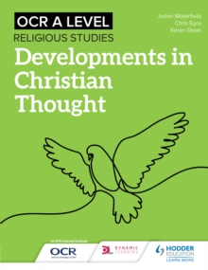 |  |  | My Revision Notes OCR A Level Religious Studies: Developments in Christian Thought  By: Eyre, Chris |  | 9781510418066 | Issued as textbook loan through College and available on Timed Loan  Also available as an e-Book.
Religious Studies | 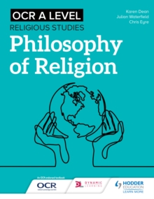 |  |  | My Revision Notes OCR A-Level Religious Studies: Philosophy of Religion  By Eyre, Chris, Waterfield, Julian |  | 9781510418042 | Issued as textbook loan through College and available on Timed Loan. Also available as an e-Book.
Religious Studies | 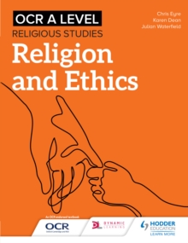 |  |  | My Revision Notes OCR A Level Religious Studies: Religion and Ethics  By: Ed), SQA (Hodder, Eyre, Chris |  | 9781510417823 | Issued as textbook loan through College and available on Timed Loan. Also available as an e-Book.
Subject | Book Image |  |  | Title & Author |  | ISBN | Comments
Sociology | 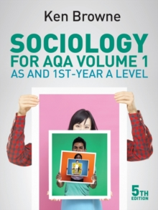 |  |  | Sociology for AQA Volume 1: AS and 1st-year A level (5th edition)  By: Browne, Ken |  | 9780745691305 | Available in classrooms, for purchase through College and as Timed Loan in the LRCs.
Sociology | 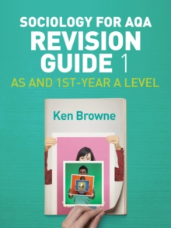 |  |  | Sociology for AQA Revision guide 1  By: Browne, Ken |  | 9781509516216 | Available in classrooms and as Timed Loan in the LRCs.

