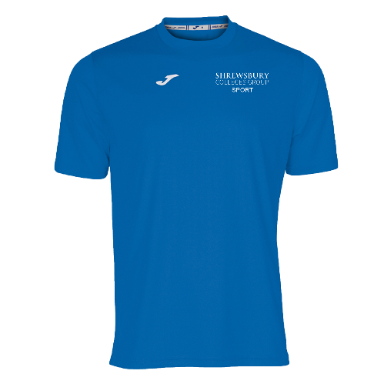

Student Kit List – Sport Pathway
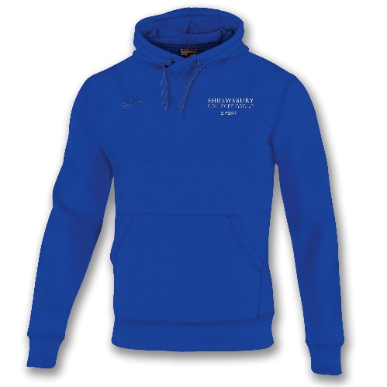
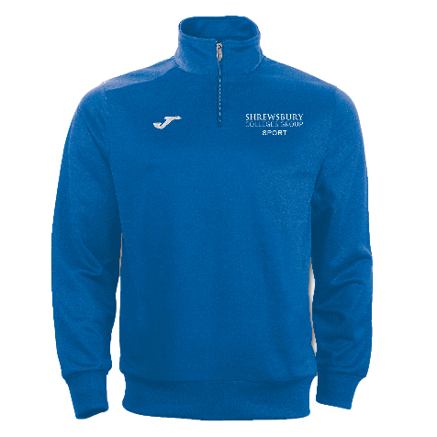

Combi T-Shirt £10
Hoodie £22
Combi ¼ Zip Sweatshirt £18
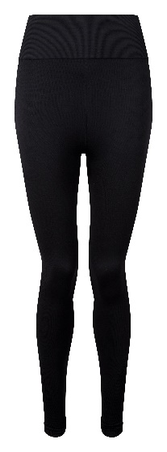
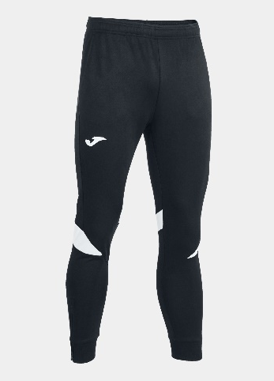
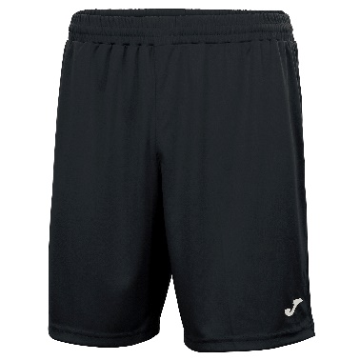

Shorts £9
Championship Trousers £23
Sport Leggings £22.99

It is mandatory for this sports kit to be worn during all college practical sessions. It is a requirement for students to purchase a minimum of 1 x Combi T-Shirt
Please use the Sporting Touch club shop website below and direct yourself to the Shrewsbury Colleges Group shop to place your order:
https://www.sportingtouch.com/club-shops/
Please note, once you place your order it is the responsibility of Sporting Touch for the fulfilment of your order and the college do not hold any accountability for the order.
If you have any questions regarding placing an order, please contact your personal tutor on the email below:
markbi@shrewsbury.ac.uk

