Dear Student & Parent/ Guardian,

Please find below a general kit list required by the students over the next two years. At the bottom of the page is a link to branded college kit that you can purchase via an online portal. There will be an expectation that students have the items in the General Personal Kit list by the 7th October (first Tuesday in October), the majority of these items can be utilised in all activities.

If you believe you will be in receipt of the college bursary please discuss this with Emma as they can support you with the purchase of essential college items. Any further question please email Emma at: emmak@shrewsy.ac.uk

General Personal Kit (All Activities)
- Waterproof jacket & trousers (breathable, with taped seams NOT water-resistant walking trousers or down jackets. These must be separate over layers)
- Walking boots and/ or approach shoes
- Base layer T-shirt (synthetic or merino wool – avoid cotton)
- Insulating mid-layer (fleece)
- Durable outdoor trousers (not jeans or joggers)
- Warm hat & gloves
- Sun hat & sunglasses (UV protection)
- Reusable water bottle or hydration system (2L minimum)
- Personal first aid kit (plasters, blister care, pain relief)
- Head torch with spare batteries
- Dry bags or waterproof stuff sacks
- Rucksack (30–40L for day trips)

Hill Walking
- Walking boots (waterproof, with ankle support)
- Walking socks (several pairs, wool or synthetic)
- Personal survival bag or bivvy bag
- Packed lunch & snacks
- Water bottle
Provided by college
- Map & compass
- Group Shelter
Nice to have but not essential
- Gaiters (optional but useful in wet/muddy terrain)
- Trekking poles (optional but helpful)

Mountain Biking
- Durable outdoor trousers or shorts (not jeans or joggers)
- Small bag
- Water bottle or hydration pack
- Trail shoes, MTB-specific footwear, approach shoes or trainers
Provided by college
- Helmet
- Cycling gloves
Nice to have but not essential
- Padded cycling shorts
If bringing your own MTB
- Multi-tool & puncture repair kit
- Spare inner tube & tyre levers
- Kit to fix own bike i.e. brake pads etc.

Watersports (e.g., kayaking, canoeing, paddleboarding, Gorge Walking)
- Water shoes/ neoprene boots or old trainers
- Waterproof dry bag
- Towel
- Swimwear
- Board shorts to go over wetsuit (for gorge walking)
Provided by college
- Wetsuit
- Buoyancy aid
- Changing mat

Rock Climbing
- Outdoor trousers (not jeans or joggers) – preferably a bit stretchy
- Approach shoes or walking boots
- Rucksack
Provided by college
- Climbing helmet
- Climbing harness
- Chalk bag & chalk
Nice to have but not essential
Climbing shoes
Level 3 Outdoors - Branded Kit

For timetabled sports sessions at college students are required to wear branded sports kit. We ask all students to have these items by the 1st October 2026. As a minimum we ask that you have the following:
1 x T-Shirt, 1 x Shorts, 1 x Jumper

Please place order through website below.

www.decostich.co.uk

School, Club & Other Shops → School/ College Shop → Shrewsbury College
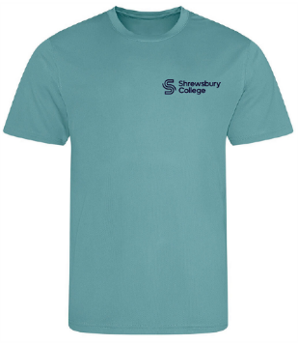
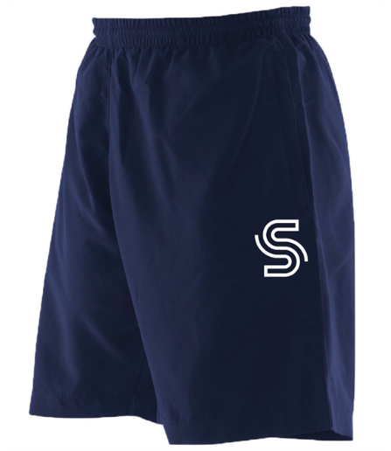

Shorts: £18
T-Shirt: £12
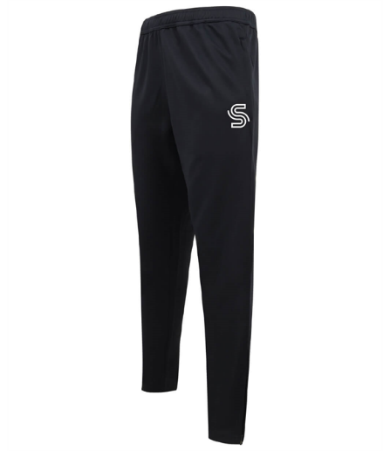
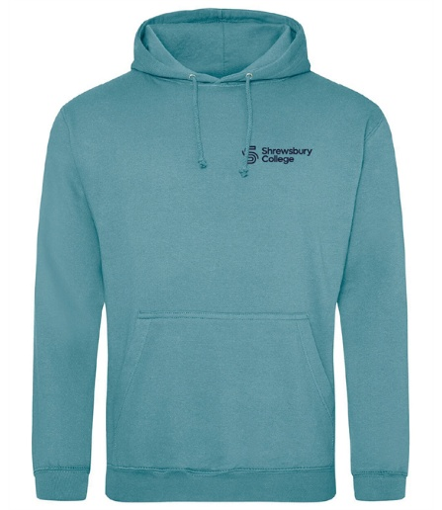
Trousers: £20
Jumper: £18

