Summer Homework
Welcome to Health and Social Care, we have three units to study this year, and we will be starting with;
‘F090: Principles of Health and Social Care’
Your pre-course reading and homework tasks are outlined below. Please complete this work and save it electronically, ready to submit via Teams in September.
Principles of Health and Social Care
Use the three hyperlinks below to help with your response

Section 1
Research (reference 1) and produce an introductory paragraph about Person-Centred Care:
- What it is
- Why person-centred care is important
- Examples of individuals who need person-centred care
In your own words, describe each of the eight Elements of Person-Centred Care (reference 2):
Use examples to illustrate each of your points
Individuality | 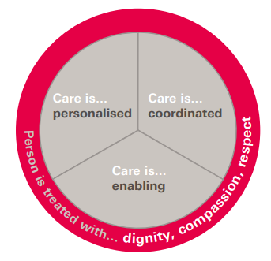
Choice
Privacy
Dignity
Respect
Rights
Independence
Partnership

Section 2
Watch the 10-minute Ted Talk (reference 3) on the Dementia Village.
- Summarise what the dementia village is about
- List three statements that you found interesting
- Select three ‘elements of person-centred care’ from above and explain how these were met in the Dementia Village
References
[1]PersonCentredCareMadeSimple.pdf
[2] Person centred values in practice training - Person Centred Care video | Person Centred Care Level 2 (VTQ) (propersoncentredcare.co.uk)
[3] Bing Videos

