Timeline: Development of the Microscope

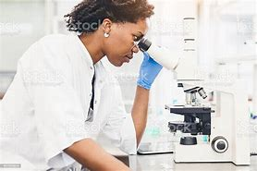
CTEC Applied Science – Summer HW
Microscopes are very important in scientific work, and have greatly contributed to our understanding of the world around us.
In CTEC, you will learn to make your own slides, how to use optical microscopes, and about different types of microscopes and why we use them.
Your task: make a timeline about how the microscope has developed over time (instructions on p7). Use the information provided about the microscope’s history, plus any research of your own that you want to include.

History of Microscopy
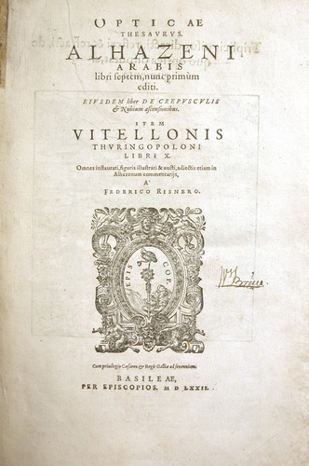
Microscopes let us view an invisible world – the objects around us that are too small to be seen with the naked eye. This history describes some of the key advances in microscopy, from simple lenses through to the sophisticated electron microscopes used today.
~710 BC – Nimrud lens
The Nimrud lens – a piece of rock crystal – may have been used as a magnifying glass or as a burning-glass to start fires by concentrating sunlight. It is later unearthed by Austen Henry Layard at the Assyrian palace of Nimrud in modern-day Iraq.
~1000 AD – Reading stone
The first vision aid, called a reading stone, is invented. It is a glass sphere placed on top of text, which it magnifies to aid readability.
~1021 AD – Book of Optics
[1]
Muslim scholar Ibn al-Haytham writes his Book of Optics [1]. It eventually transforms how light and vision are understood.
Cover page of the Latin translation of Kitāb al-Manāẓir ("Book of Optics"), 1572
1284 – First eyeglasses
In Italy, Salvino D’Armate is credited with inventing the first wearable eyeglasses, when glass-blown lenses are developed and held together by wooden frames for the first time. These will soon be known as spectacles.
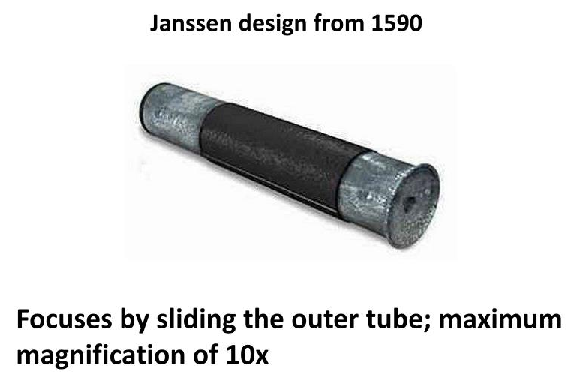
1590 – Early microscope
[2]
In a town called Middelberg in the Netherlands, a spectacle-maker called Zacharias Janssen and his son Hans place multiple lenses in a tube [2]. They observe that objects viewed in front of the tube appear greatly enlarged. This is a forerunner of the compound microscope and the telescope.
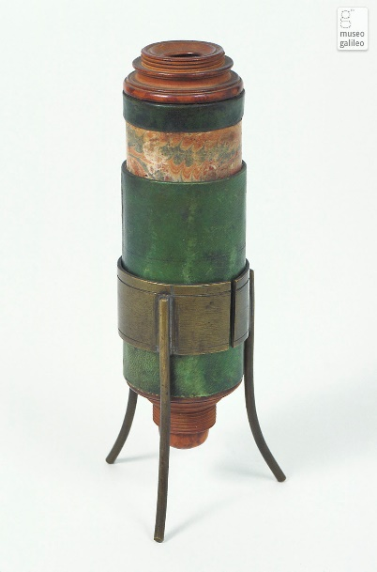
1609 – Compound microscope
Galileo Galilei develops a compound microscope [3] with a convex and a concave lens, possibly having heard about the microscope in the Netherlands. He continues refining and improving the microscope, and by 1624 creates one containing three bi-convex lenses that can achieve up to 30x magnification. Galileo presents his device to a science academy (group) called The Linceans. In 1625, Giovanni Faber, one of the other academy members, names it the “microscope” meaning ‘small-seeing’. This makes the device comparable to the already named “telescope” meaning ‘far-seeing’.
[3]
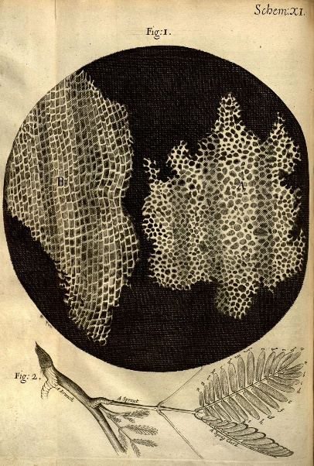
1665 – Discovery of cells
Robert Hooke is a true Renaissance man, often dubbed “England’s Leonardo”. Among his many scientific pursuits is microscopy. He uses a simple, single-lens microscope illuminated by a candle.
In 1665, Hooke publishes a book entitled Micrographia. Hooke introduces the idea of a ‘cell’ which he finds while observing cork under a microscope. He dubs it a cell because the cells in the cork look like honeycomb cells. As well as images of cork [4], his book also includes drawings of hairs on a nettle and detailed images of fly eyes.
[4]

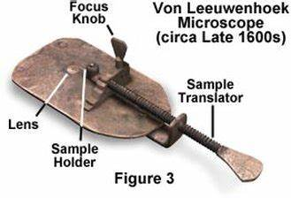
1678 – Living cells first seen
Antonie van Leeuwenhoek makes many of the early discoveries in microscopy, leading to his nickname as ‘the father of microscopy’. He builds a simple microscope with one lens [5], and invents new methods for making lenses that allow for magnifications of up to 270x. Among his discoveries are bacteria, protozoa, spermatozoa and blood cells.
[5]
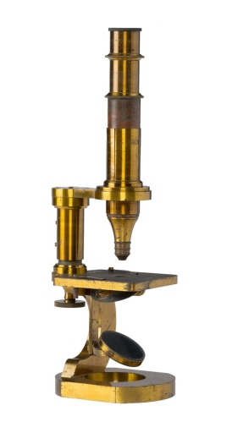
1846 – Microscopes mass produced
In Germany, Carl Zeiss sets up a manufacturing company, which still exists today, and starts the first mass production of microscopes. The firm becomes renowned (well known) for the quality of their microscopes, and helps propel microscopy into the mainstream of science. Microscopes become more abundant in scientific universities.
[6]
A microscope from Zeiss’ 1862 collection

1931 – Transmission electron microscope invented
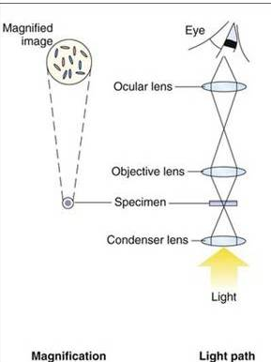
Up until 1931, all microscopes operate through light microscopy. Diagram [7] shows how the lenses line up, for light to pass through and be refracted, eventually producing an image.
However, the problem with light microscopy, is that the wavelengths of photons (particles of light) cause magnification to max out at around 2000x – 2500x. These levels of magnification allow for viewing cells and bacteria, but not atoms.
Ernst Ruska and Max Knoll design and build the first transmission electron microscope (TEM), based on an idea of Leo Szilard. The electron microscope depends on electrons, not light, to view an object. Electrons have significantly shorter wavelengths than photons of light, allowing for greater magnification. Diagram [8] shows the electron gun in position to fire electrons down through a series of lenses to create an image of the specimen.
[7]
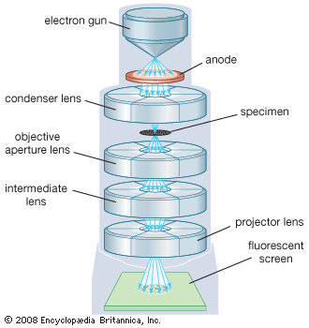
Modern TEMs can visualise objects as small as the diameter of an atom.
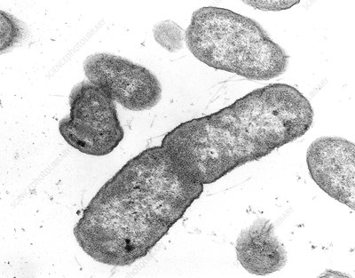
[9]
Bacteria seen using a TEM
[8]
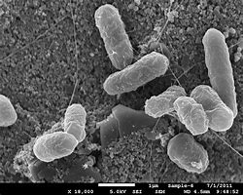
1942 – Scanning electron microscope
Ernst Ruska goes on and builds the first scanning electron microscope (SEM), which transmits a beam of electrons across the surface of a specimen.
Bacteria seen using a SEM
[10]

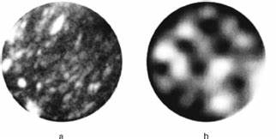
1951 – The first atom is seen
Erwin Wilhelm Müller and his PhD student invent the Field Ion Microscope (FIM) – the first microscope capable of viewing atoms directly. Their experiment involves electrifying a piece of tungsten metal inside a chamber of helium, and allows an image of helium atoms to form.
[11]
- A graphite fibre and a (b) carbon nanotube seen with an FIM

1978 – Confocal laser scanning microscope
Thomas and Christoph Cremer develop the first practical confocal laser scanning microscope, which scans an object using a focused laser beam.

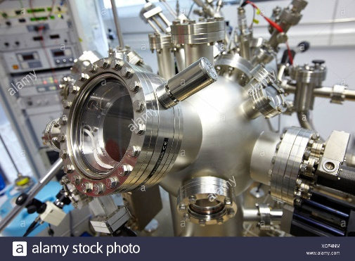
1981 - Scanning tunnelling microscope
Gerd Binnig and Heinrich Rohrer invent the scanning tunnelling microscope (STM). The STM ‘sees’ by measuring interactions between atoms, rather than by using light or electrons. It can visualise individual atoms within materials, provides high quality images of atoms, and allows scientists to manipulate atoms to see how they behave.
[12]

Conclusion
Microscopy continues to advance even now. Today, inventions in microscopy tend to be achieved by teams of scientists in labs and universities around the world. These scientists are pushing the boundaries of what we know about the building blocks of our worlds.
The above timeline of advances in microscopy is not an exhaustive timeline, but shows some of the more important developments that led us to understand the world at a more granular level than ever before.
Sources
www.sciencelearn.org.nz/resources/1692-history-of-microscopy-timeline
https://scopedetective.com/history-and-timeline-of-microscopy/?utm_content=cmp-true

Images:
[1] University of Oklahoma History of Science Collections et BnF Gallica : http://gallica.bnf.fr/ark:/12148/bpt6k312873d.r=Haytham?rk=407727;2
[2] https://www.slideserve.com/fia/7-th-microscopy-and-the-development-of-cell-theory
[3] https://catalogue.museogalileo.it/gallery/CompoundMicroscopeInv3247.html
[4] https://www.britannica.com/biography/Robert-Hooke
[5] https://discoveries-project.weebly.com/anton-van-leeuwenhoek.html
[6] https://www.zeiss.com/corporate/en/about-us/past/history/carl-zeiss.html
[7] https://wwwverma.blogspot.com/2020/03/light-microscope-principle-and.html
[8] https://www.britannica.com/technology/transmission-electron-microscope
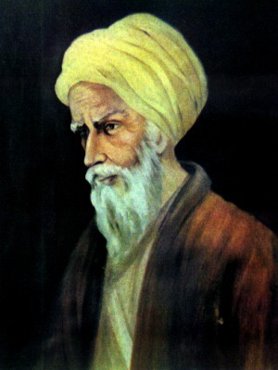 | 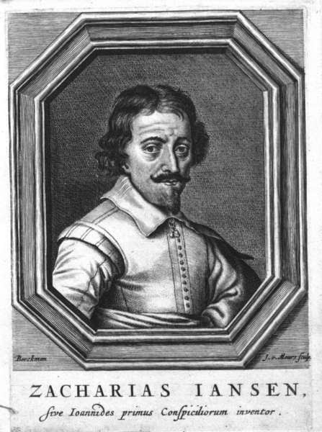 | 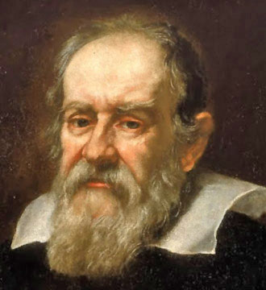
Ibn al-Haytham  (965 - 1039) | Zacharias Jansen  (1585 – pre 1632) | Galileo Galilei  (1564 - 1642)
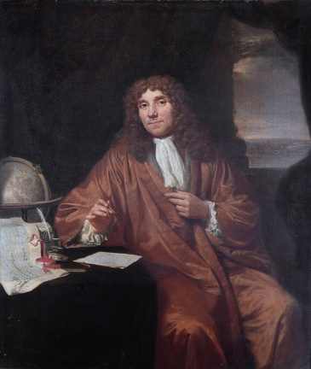 | 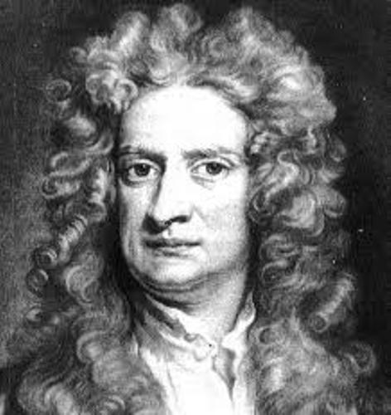 | 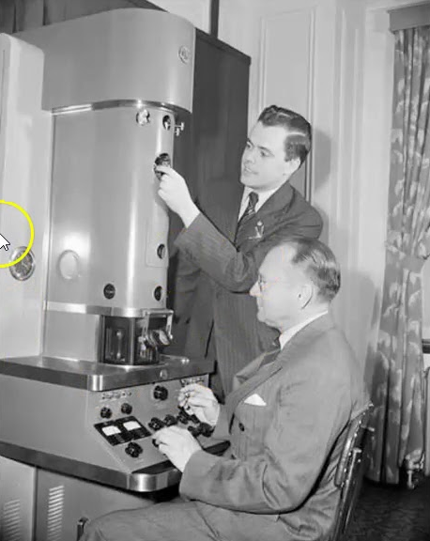
Anton Van Leeuwenhoek (1632 - 1723) | Robert Hooke  (1635 - 1703) | Ernst Ruska (1906-1988) &  Max Knoll (1897-1969)
[9] TEM Micrograph Gallery (gettysburg.edu)
[10] https://medicalxpress.com/news/2015-11-specific-gut-bacteria-severe-diarrhea.html
[11] https://www.researchgate.net/figure/Field-ion-microscope-images-of-a-graphite-fiber-a-and-carbon-nanotube-of-diameter_fig1_241294480
[12] https://c8.alamy.com/comp/XCF4NM/scanning-tunneling-microscope-stm-in-ultra-high-vacuum-uhv-nanophysics-laboratory-materials-physics-center-is-a-joint-XCF4NM.jpg

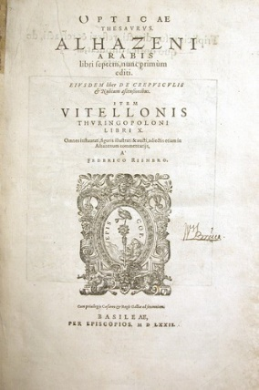 | 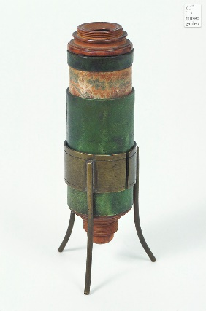 | 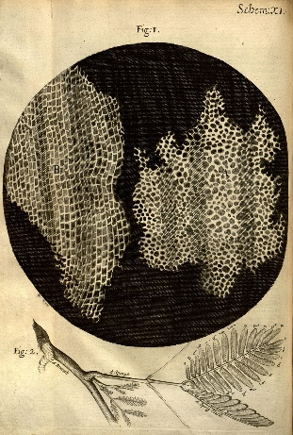
 |  | 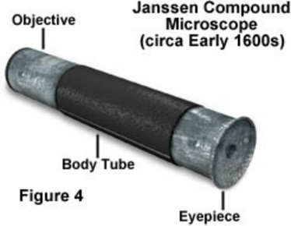

Instructions

- Get 2 pieces of plain paper and overlap them, just enough to ensure they can be taped together.
- Tape them together to make a long thin piece of paper.
- Draw a horizontal line in pencil across the middle of your paper. Afterwards, your paper should look like this:
overlap and tape
Paper |  | Paper
line drawn in pencil with a ruler

- You may arrange your work as landscape or portrait.

- Make the timeline.

  - On the pencil line, label the years when key advances in microscope development were made.

Above and below your pencil line, include information such as:
  - what the discovery/development was;
  - who made it;
  - what was the new development (e.g. a brief description of what the microscope could do now);
  - cut out and stick picture on your timeline – you don’t have to use all of them

This is not an exercise in writing tiny to include every bit of detail. Make sure to include the important points and get rid of the “fluff”. Also ensure that your timeline is easy to read and appealing to study from—if you like looking at it, chances are you’ll look at it (and study it) more.

- Write your name on your completed timeline and hand it in during your first CTEC Applied Science lesson.

On the next page you will find some examples of other students’ timelines on a different topic (these are just a guide to point you in the right direction):

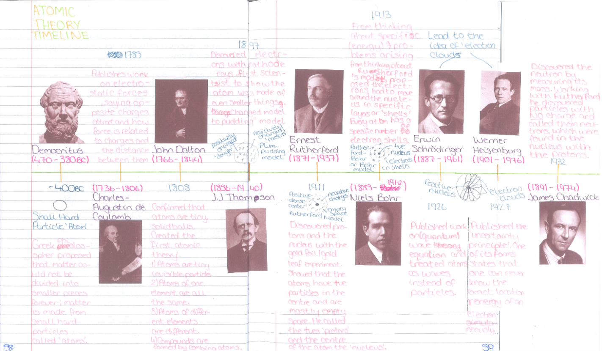
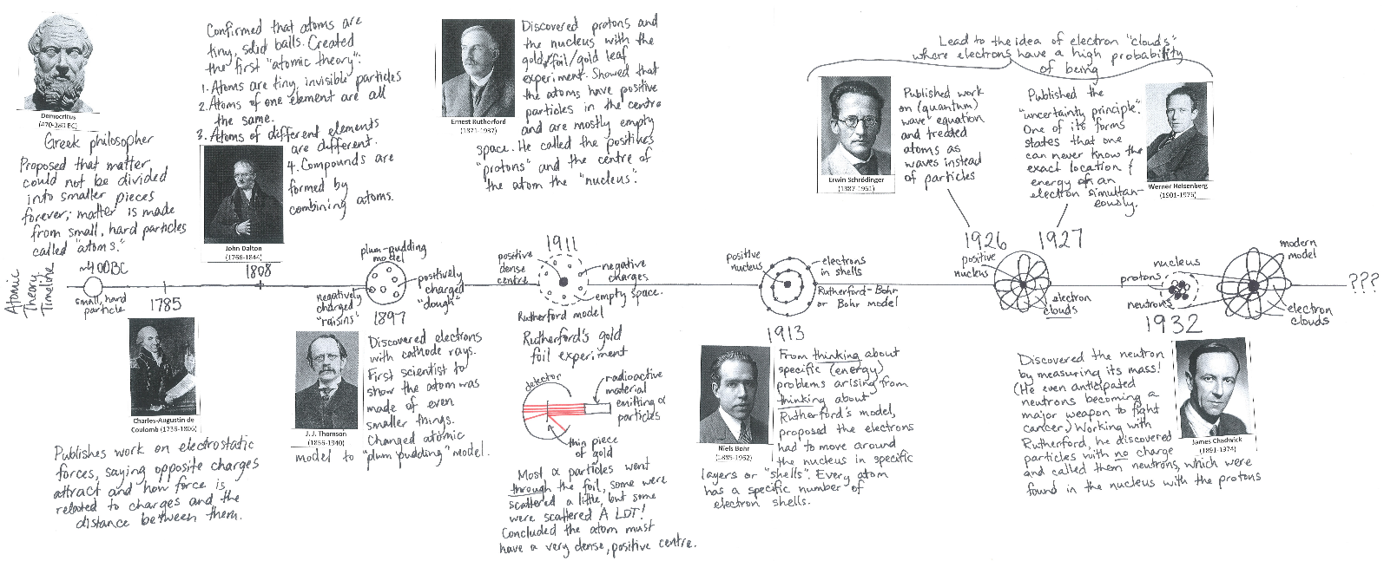
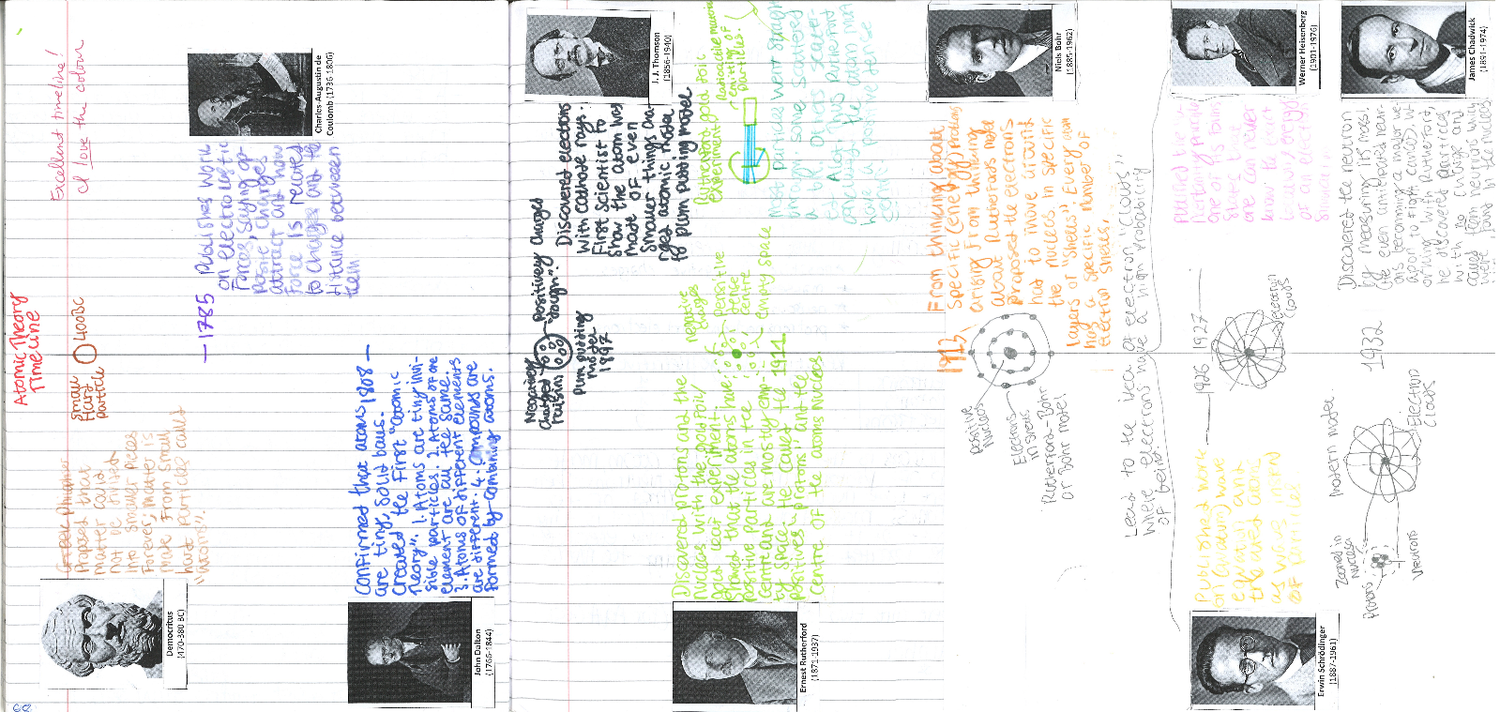
Some examples of other students’ timelines:

