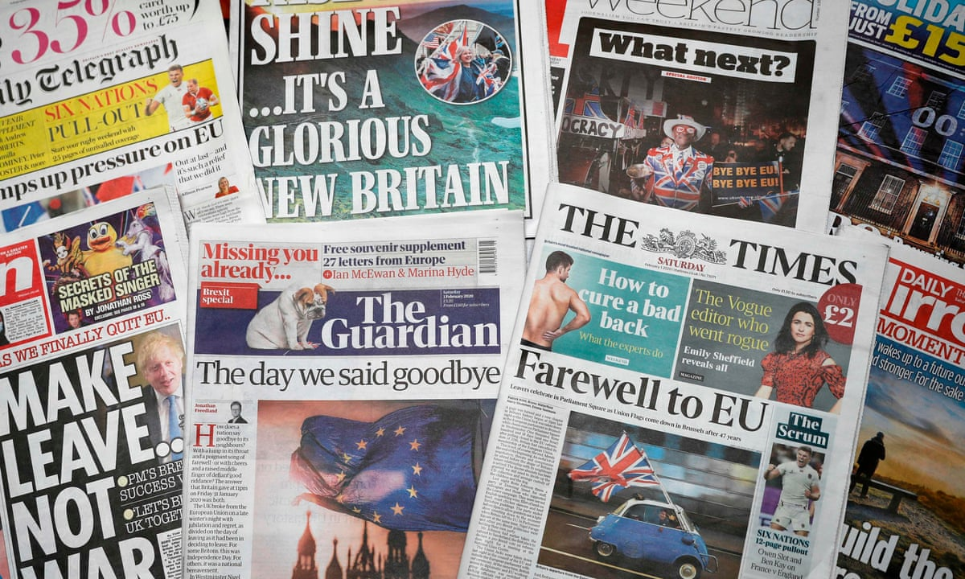
A-Level Media Studies:
Pre-enrolment ‘Summer’ Task
The below task has been designed to introduce you to the content, knowledge and skills that are integral to the A- level Media Studies course.
To show us where you're at with your media knowledge and interests, you must complete the below task before you start the course in September:
TASK: A 450-550-word essay analysing the media language in two different front pages of any UK newspaper from the below list:

The Sun, The Times, The Daily Mail, The Guardian, The Daily Telegraph, Daily Mirror, Daily Express – must be from June 2026 onwards.
Tips
- When writing your essay, think about 1) what media language features are included on your chosen front pages, then 2) what meaning is created by these language features?
- You can find daily front pages here Tomorrow's Papers Today - UK Front Pages - Latest Newspaper Headlines or here The Papers - BBC News.
- It is advised you write approx. 250 words per front page = 500 words total.
- You must include – an image of the front page you are analysing next to your essay, a title including the name of the papers and the date it was published, and the word count for each front cover analysis (see exemplars for structure guidance).
- This must be your own work. Any suspected use of AI generated work will be asked for resubmission.
Save your work digitally. You will be given instructions for digital submission in your first week.

Important! A-Level Media Studies is an academic qualification. It involves a large amount of written essay-based assessments such as this in which key terminology and academic theories are used appropriately to analyse a range of media texts and to discuss the media industry.

See overleaf for two exemplars and a newspaper language glossary.
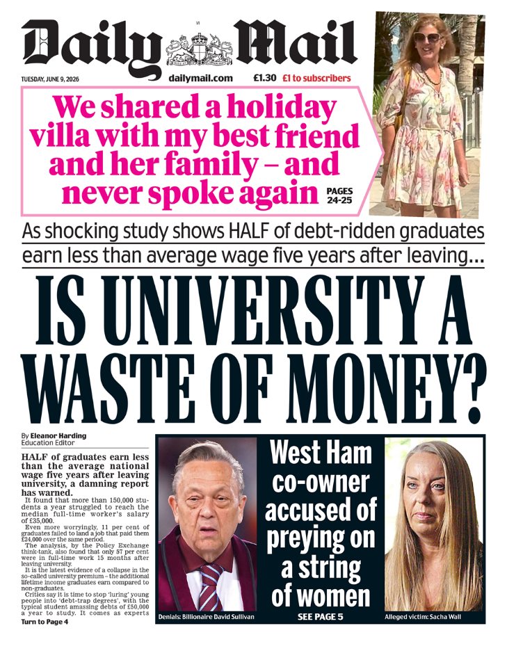
Exemplar 1: The Daily Mail - June 9th 2026 (word count 233)
The front page uses tabloid conventions to create a loud and sensational overall meaning, designed to grab the reader’s attention quickly. The masthead, “Daily Mail,” is large and traditional, giving a sense of authority, but this contrasts with the more dramatic and informal style of the rest of the page.
The most striking feature is the main headline, “IS UNIVERSITY A WASTE OF MONEY?”, which is written in very large, bold text. This suggests importance and urgency, encouraging readers to question education. The use of a question directly addresses the audience and creates debate. The smaller subheading beneath it provides anchorage, explaining that “HALF of debt-ridden graduates earn less than average wage.” This supports the headline by giving a statistic, guiding the reader’s interpretation towards a negative view of university.
In addition, the pink box containing the story “We shared a holiday villa…” acts as a secondary headline. Its bright colour and personal tone make it appear more informal and gossip-based, a typical tabloid feature. The splash image next to it, showing a person on holiday, reinforces this narrative and adds a sense of realism, drawing the audience in emotionally.
Other images and text, such as the story about a football club owner, continue the sensational tone, focusing on scandal. Overall, the combination of bold headlines, striking images, and selective anchorage creates a front page that prioritises entertainment and strong opinions over neutrality.

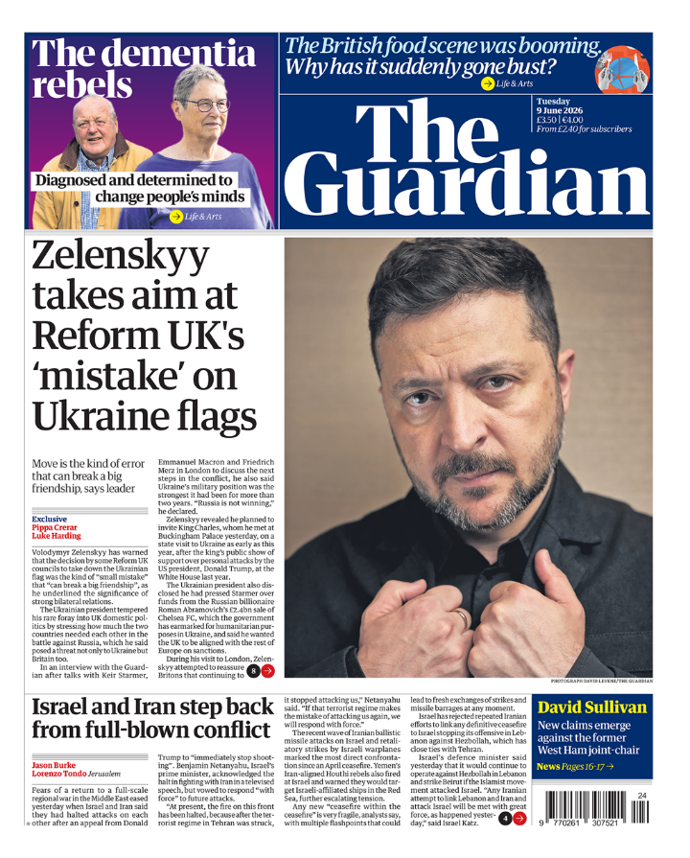
Exemplar 2: The Guardian - June 9th 2026 (word count 254)
This front page uses media language to create a serious and informative overall meaning. The masthead, “The Guardian,” is large and placed at the top of the page in a formal font, which establishes authority and credibility. This suggests the newspaper is focused on reliable, high-quality journalism.
The main headline, “Zelenskyy takes aim at Reform UK’s ‘mistake’ on Ukraine flags,” is written clearly and avoids overly sensational language. The use of quotation marks suggests accuracy and gives the impression that the report is based on real statements. The subheading adds anchorage by explaining that the issue could “break a big friendship,” guiding the reader to understand the seriousness of the political situation.
A large splash image dominates the right-hand side of the page, showing a close-up portrait of Zelensky giving direct address, creating a connection with the audience. The size and placement of this image emphasise the importance of the story and draws the reader’s attention. The plain background and direct composition support a formal tone rather than an informal or exaggerated one.
Other text on the page, such as “Israel and Iran step back from full-blown conflict,” continues this focus on important global events. The wording is careful and controlled, which reinforces the idea that the newspaper aims to inform rather than simply entertain.
Smaller elements, like “The dementia rebels,” use a softer, human-interest approach, but still remain respectful. Overall, the combination of structured headlines, clear anchorage, and formal layout creates a front page that communicates seriousness and importance through its media language.
TOTAL WORD COUNT: 487

NEWSPAPER MEDIA LANGUAGE GLOSSARY
Use as many of these key terms as possible in your analysis of your chosen front pages:

TABLOID: Newspapers that feature compact, smaller-than-average pages, numerous photographs, and shorter, often sensational news stories such as celebrity gossip and scandals

BROADSHEET: Large-sized traditional newspaper, usually informative, formal, and relies on text and copy rather than images. Reports on serious topics in an educational manner such as politics
- HARD NEWS: Serious news topics e.g. politics, education, health, war & conflict, crime
- SOFT NEWS: Less serious topics e.g. celebrity gossip, sport, entertainment, lifestyle

TYPOGRAPHY: Font sizes and styles used to identify the most important aspects of a newspaper cover and affect how we read the words.

SERIF FONTS: Used conventionally in broadsheets to connote tradition and authority.

SANS SERIF FONTS: Have impact, direct, modern connotations and can be read quickly.

MASTHEAD: The logo of a newspaper which uses typography and sometimes images to create a distinctive brand image

HEADLINE: A title which introduces the story. Often shorter and pithier in tabloids compared to broadsheets.

SUBHEADING: Adds additional information to the headline.

SKYLINE: A panel which tells the reader about other stories to tempt them inside.

BYLINE: Gives the writer's name and sometimes an image of them.

JUMP LINE: Text which directs you to another page where the story continues, e.g. 'Continues on page 7'

CAPTION: Text which accompanies an image to anchor its meaning

PULL QUOTE: A quote from a story which appears in larger font in the middle of the story to intrigue the reader

STANDFIRST: The main introductory paragraph of an article which appears in larger font to introduce the topic and focus

COPY: A general term for any text included on the cover

CROPPING: cutting the edges from an image to accentuate a particular focus and remove any distracting details

RESIZING: Aka image scaling. Making an image bigger or smaller in terms of the space it occupies to guide the readers' focus and attention. Different newspapers may use the same images but resized according to how much focus they want the reader to place on them.

PLUGS/EARS: Small information boxes either side of the masthead or headline.

ANCHORS: Text which adds particular preferred readings to images (e.g. captions) and guide the reader's interpretation

PREFERRED READINGS: The meaning that the newspaper producer intends the audience to accept

SPLASH: The main front-page story which is given most prominence

TEXT TO IMAGE RATIO: The balance between images and text

