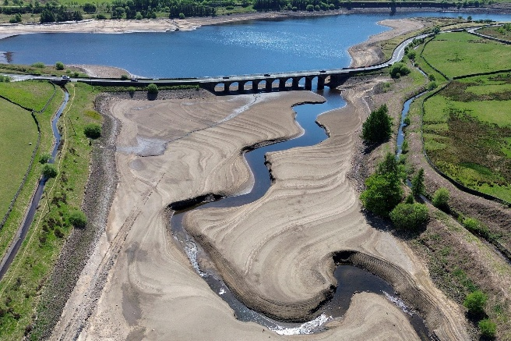
A level Geography
Year 11 Summer Homework

England could face drinking water shortages within a decade unless new reservoirs are built, a minister has claimed. In May 2025 the UK Government announced that it was going to speed up the construction of around 7 new reservoirs.

Use the maps, articles and links below to answer the questions on the next page. Use the resources here as a starting point – there is a lot more on the internet!
You should bring the work to your first lesson in September. It can be done by hand or on electronically. This is preparation for an initial assessment which will be done a week or two into the course. You will be asked to answer the question…..
‘Assess the view that new reservoirs should be built in the UK’

Seven new water reservoirs planned for England - mapped
Government fast-tracks new reservoirs to secure water supply - BBC News
Bing Videos ITV news clip
Exceptionally low river flows forecast across UK as drought threat grows | Drought | The Guardian
Inside the quiet market town bracing for Labour’s new 55bn-litre reservoir
Water Crisis Solutions: Beyond Reservoirs to Sustainable Water Management
Water: Why Abingdon’s mega reservoir is making waves

Key Terms
Water Insecurity It occurs when the demand for safe, usable water in a given area exceeds the supply,
Reservoir The new reservoirs planned in the UK generally involve digging a very large hole and building banks around it. Water will be diverted into these new lakes from nearby rivers.
NIMBY ‘Not In My Back Yard’ A group of people who protest against local developments
Privatised Water Company In the UK water is owned by and managed by private companies like Severn Trent who want to make a profit for their shareholders. However, the Government can have an influence through the regulator Ofwat and by making planning permission easier.

Questions
- Use the maps on the resource sheet and your reading to explain why the reservoirs are going to be built. Quote evidence from the maps and your research.

- Assess the likely costs and benefits of constructing new reservoirs in the UK.
Produce a table like this. Should be around one side of A4.

Costs | Benefits

Once you have done the table do the following activities.
- Classify your points into social, economic and environmental impacts
- Which are the most important costs and benefits? Choose one or two from each column and explain why they are the most important.

- Explain how the following groups of people may feel about the new reservoirs. Give reasons why.
Produce a mind map like this

- Is building reservoirs the only solution to the issue of possible water shortages in the UK? Research alternative approaches. Use the links and your own research.
Which ones do you think should be invested in? Give reasons why.
Three Gorges Dam
Tryweryn Dam
Narmada Dam
Grand Ethiopian Renaissance Dam

- Extension. Reservoirs and dams are not only about supplying water but often have wider social and political impacts. Research any/ all of these dams and find out the wider implications of their construction.

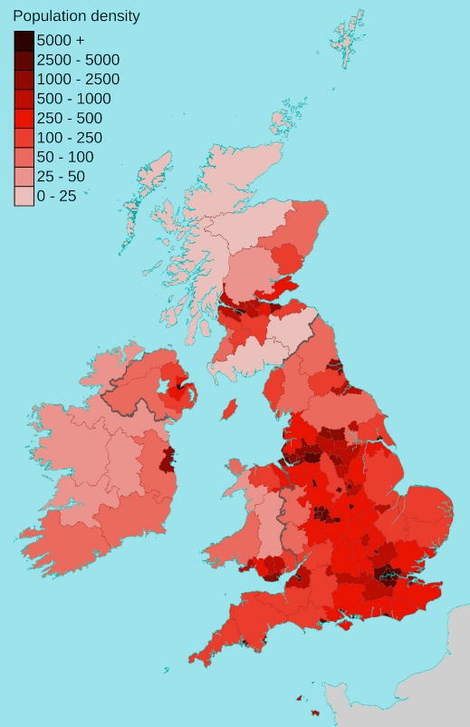
Resource 1 Maps
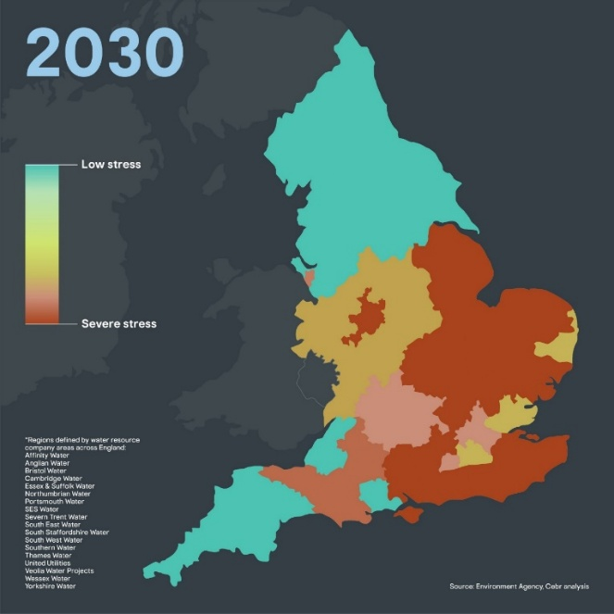

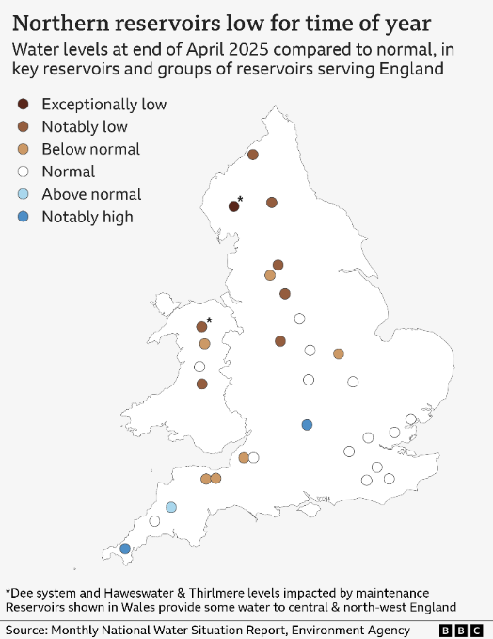
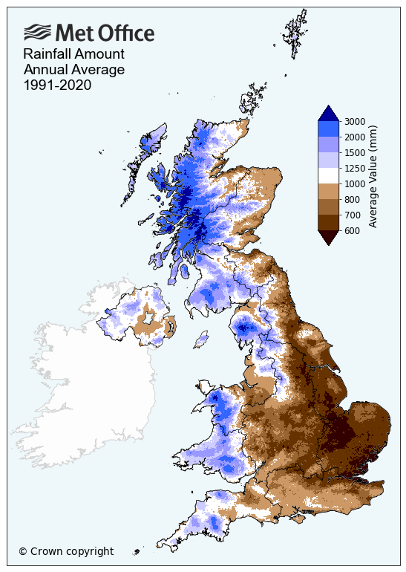
Resource 2 – BBC Article
29 May 2025

England could face drinking water shortages within a decade unless new reservoirs are built, a minister has claimed.
The warning comes as the government announced it was speeding up the planning process for two reservoir projects. But overriding local objections can be unpopular and the reservoirs could still be more than a decade away from opening. Household consumption of water may also need to fall to secure supplies amid rising temperatures and a growing population, scientists warn.
The announcement means that final decisions about the proposed Fens Reservoir in Cambridgeshire and the Lincolnshire Reservoir will be taken by Environment Secretary Steve Reed, rather than at a local level. This change amounts to "slashing red tape to make the planning process faster", according to Water Minister Emma Hardy.
Speaking to BBC Breakfast, she said: "This is really important because if we don't build the reservoirs, we're going to be running out of the drinking water that we need by the mid-2030s."
The reservoirs in Cambridgeshire and Lincolnshire are currently pencilled for completion in 2036 and 2040 respectively.
They "would provide more resilience to future droughts in a part of the country that is already dry and where there is high demand for water", said Dr Glenn Watts, water science director at the UK Centre for Ecology & Hydrology.
Reservoirs can help protect against the impacts of drought by collecting excess rainfall during wet periods. With climate change likely to bring hotter, drier summers, the chances of drought could increase in the decades ahead, the Met Office says.
These preparations have been brought into sharp focus by this year's exceptionally dry spring. North-west England is officially in drought, according to the Environment Agency, which says it is watching the situation closely in other regions.
Extra demand from new houses, data centres and other sectors could further squeeze supplies, but no major reservoirs have been completed in England since 1992, shortly after the water sector was privatised. Last year the government and water companies announced proposals to build nine new reservoirs by 2050.
Together they have the potential to provide 670 million litres of extra water per day, they say. That's in addition to the Havant Thicket reservoir project in Hampshire, which is already under way and is expected to be completed by 2031.
The government also says that it intends to pass legislation to automatically make the other seven proposed reservoirs "nationally significant", so the final decision would be taken by national government. "Reservoir projects are very complex infrastructure projects that are slow to take forward, and so anything that can be done to streamline that process can be a positive thing," said David Porter, senior vice president of the Institution of Civil Engineers (ICE).

