SCG A-level Physical Education summer homework:
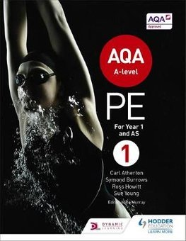
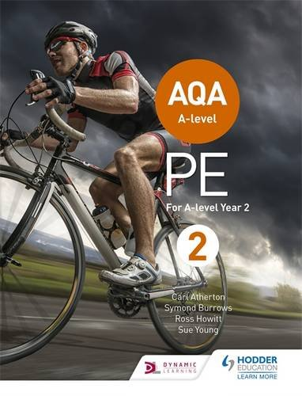
Over the first year of A-level Physical Education at Shrewsbury Colleges Group you will have the opportunity to study four key areas of the course: Anatomy and Physiology; Acquisition of Skill; Sociology of Sport and Practical / Coursework.
Below are the three activities / challenges you should attempt prior to starting the PE course, one focused on each topics area to give you a taste of the things you will learn at SCG.

Task 1: Anatomy and Physiology. | Completed?
Record your resting heart rate, complete 30 burpees, record your heart rate at 1-minute intervals until it returns to normal.

Task 2: Acquisition of skill. | Completed?
Learn to juggle! Follows my tips, or watch a YouTube tutorial and try and teach yourself to juggle. Record the maximum amount of time you can juggle each practice session to measure your progress.

Task 3: Sociology. | Completed?
Research the benefits of 30 minute for Physical activity each day for 6 weeks and create a mini poster representing the key benefits.

Task 4: NEA coursework. | Completed?
Complete a movement analysis of the badminton player performing an overhead clear – using the preparation phase as an example.

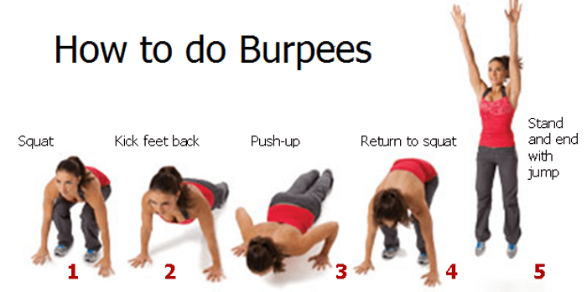
Activity 1: A&P
HR’s response to BURPEES!

Use the graph at the bottom of the page to roughly plot your 5 key changes to your HR during exercise:
Record your heart rates response to exercise in the table below:
Heart Rate (HR) at rest | BPM
HR just before exercise | BPM
HR after 10 Burpes | BPM
HR after 10 more Burpes | BPM
HR after 10 more Burpes | BPM
HR after 1 minute rest | BPM
HR after 2 minutes rest | BPM
HR after 3 minutes rest | BPM
HR after 4 minutes rest | BPM
HR after 5 minutes rest | BPM
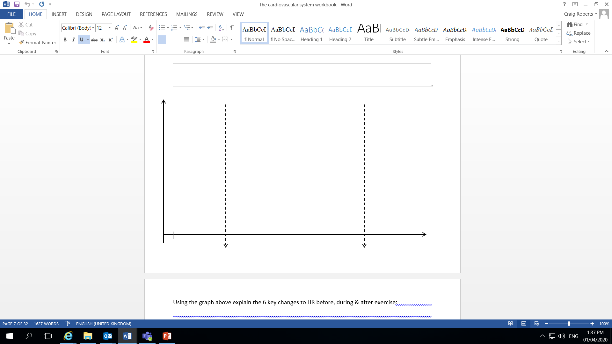
Start of exercise
End of exercise

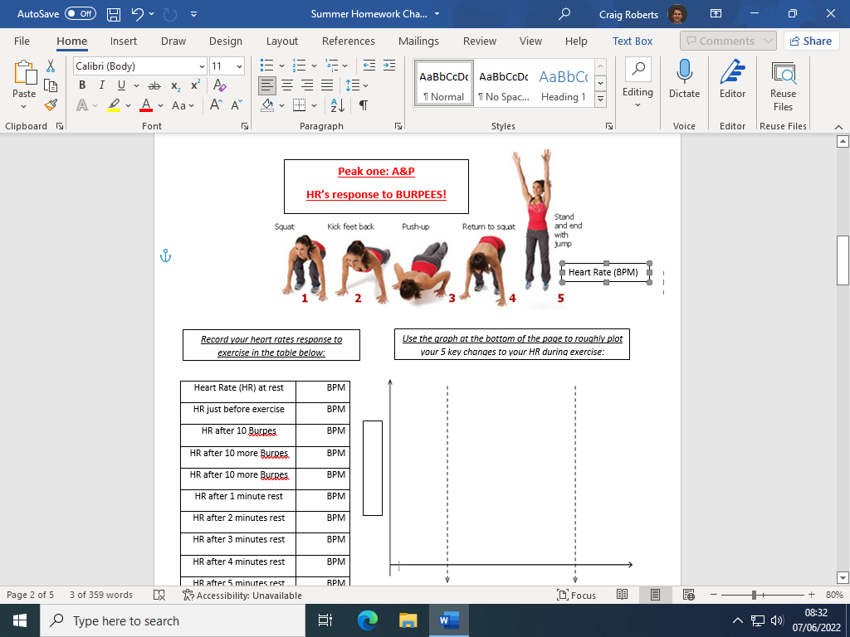

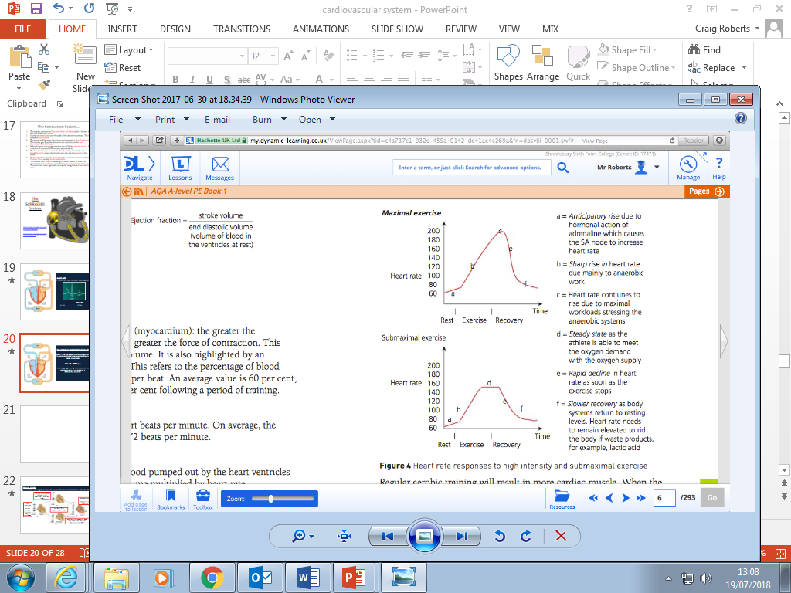

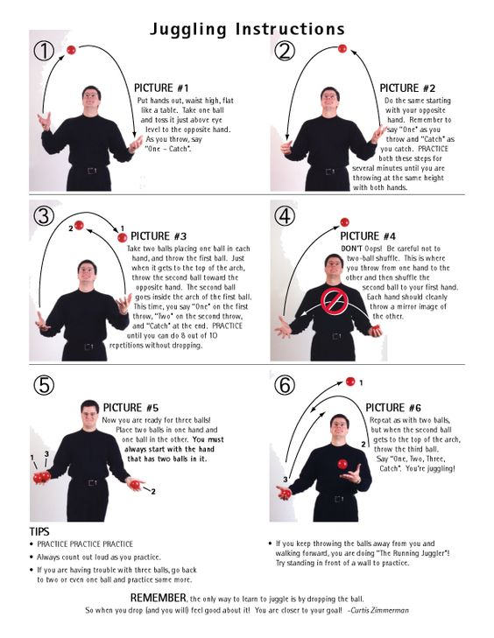
Activity 2: SKILL - Stages of learning (to juggle!)

We are always learning, sport is a great example of this. Your second challenge is to learn to juggle (or a new juggling trick if you’re already an expert!) Keep a record of the amount of time you can juggle the ball for twice a week and record you progress. Once you have done this for a few weeks, see if your improvements match up with the three stages of learning:
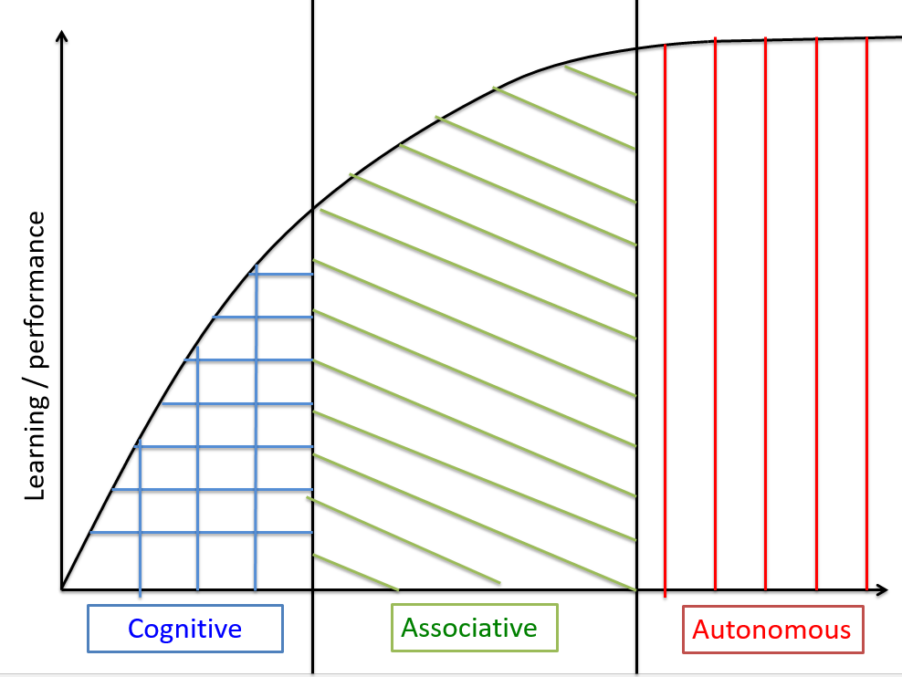

Session | Best time:
1
2
3
4
5
6
7
8
9
10

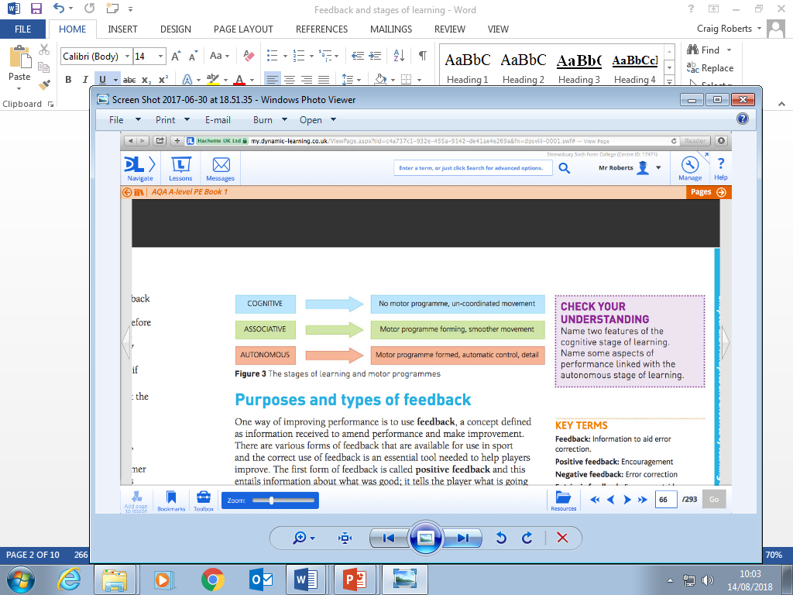

Activity 3 : SOCIO - Benefits of exercise

The government recommends 30 minutes of exercise a day. This highlights the importance of exercise for all of us, but what are these benefits? Draw three cartoon pictures to represent 3 key benefits of exercise for our 1) Physical, 2) Social 3) Mental Wellbeing and underneath each write a key word to explain the picture.
Physical benefits of exercise
Social benefits of exercise
Mental benefits of exercise

Activity 4 : NEA - Coursework

Using the preparation phase as an example, complete the anatomical annotations of the elite performer performing an overhead clear for the 2 execution phases and the recovery phase.
Preparation of an overhead clear
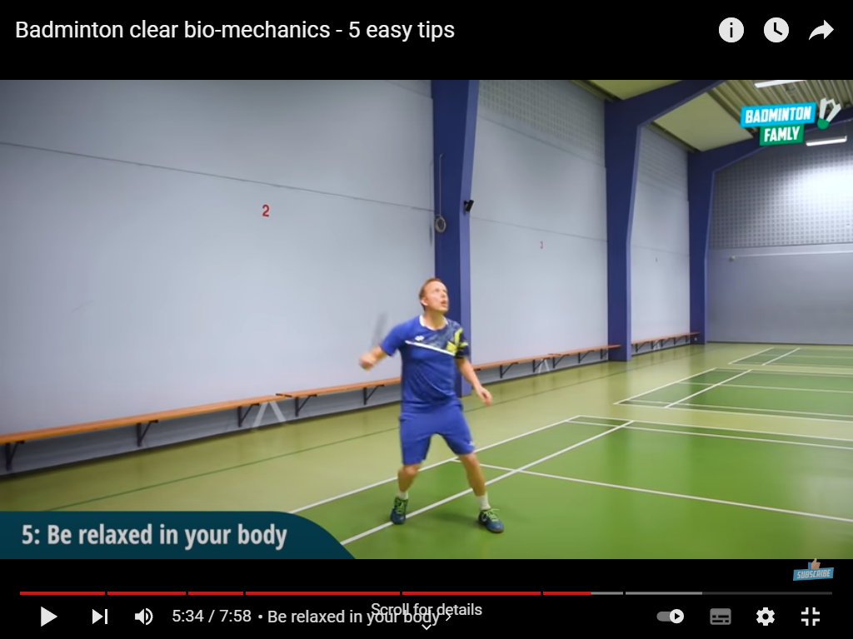
The elite performers has neck extension, caused by contraction of his splenius cervicis and capitis. This allows him to watch the flight of the shuttle and predict when it is going to land.

The elite performer has his shoulders slightly abducted caused by contraction of his middle deltoid and his elbows slightly flexed by contracting his bicep brachii, this arm action allows him to stay balanced whilst he moves into position.

The elite performer has His hips slightly flexed by contraction of his iliopsoas and his knees slightly flexed by contracting his hamstrings. This action allows him to stay agile by lowing his centre of gravity and being prepared to drive off in any required direction quickly.

The elite performer has ankle plantar flexion caused by contraction of his gastrocnemius. This action keeps him on his toes, improving his agility as he reacts to the flight of the shuttle.

Initial execution phase of an overhead clear
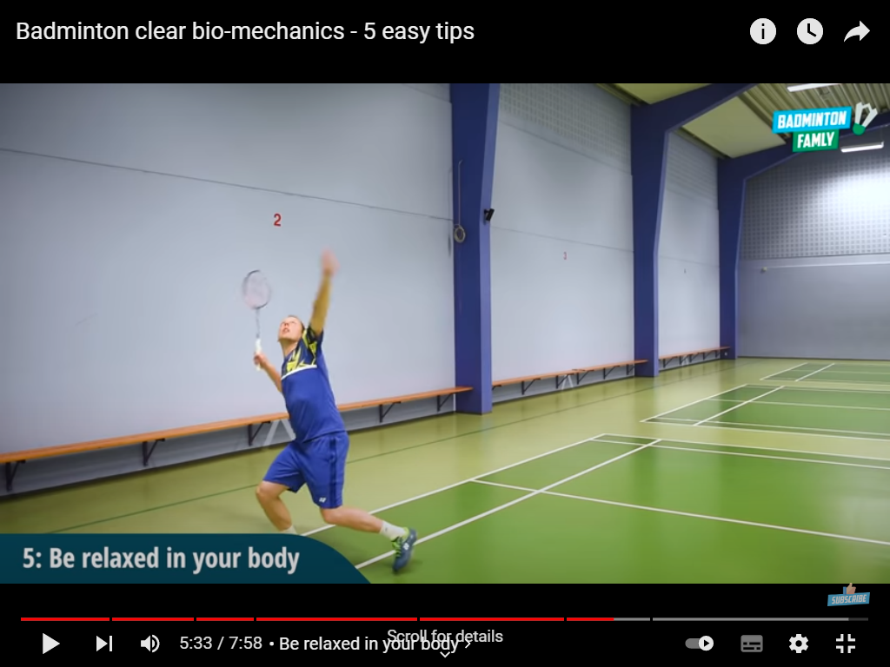
The elite performer . .

The elite performer . .

The elite performer . .

The elite performer . .

latter execution phase of an overhead clear
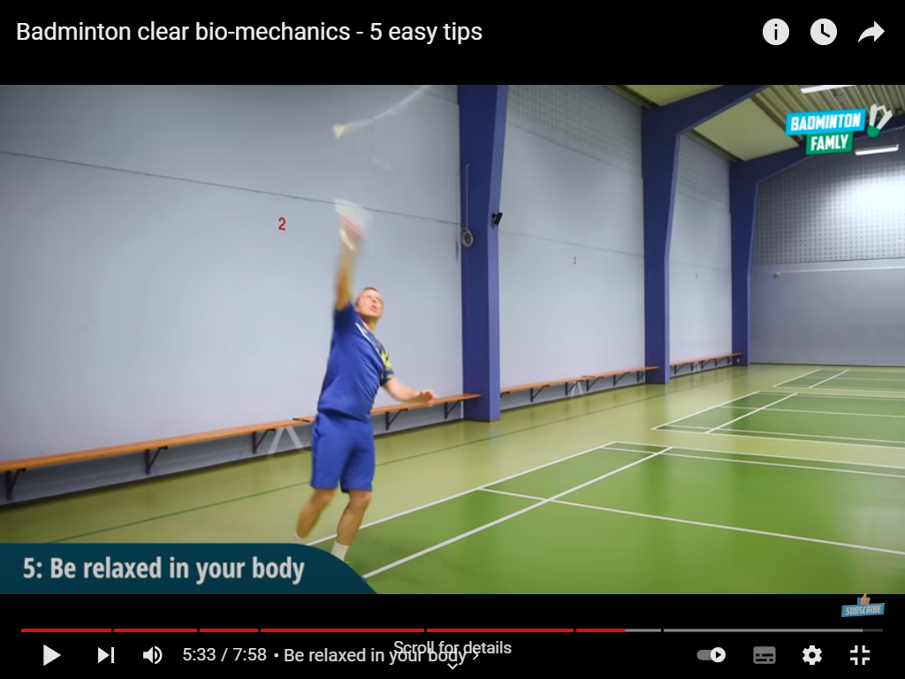
The elite performer . .

The elite performer . .

The elite performer . .

The elite performer . .

Recovery phase of an overhead clear
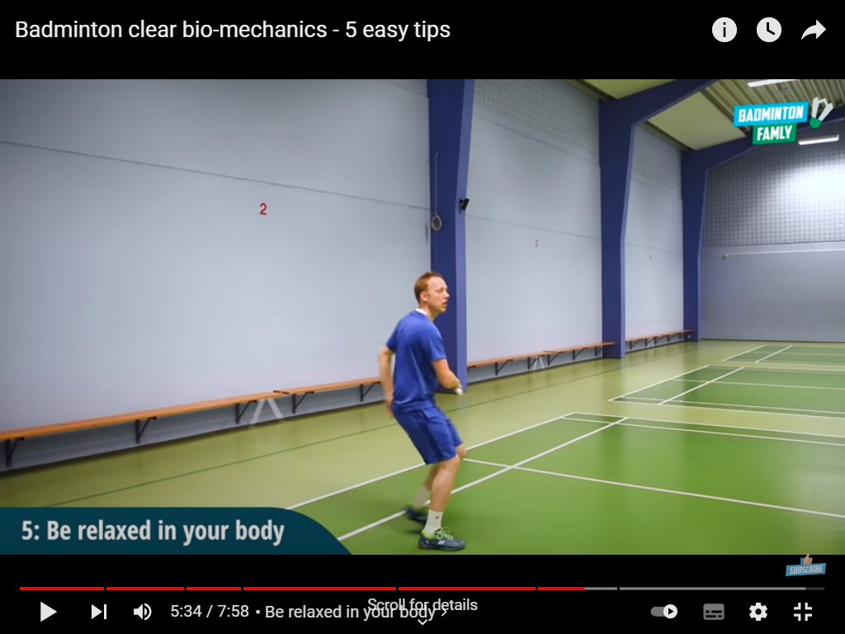
The elite performer . .

The elite performer . .

The elite performer . .

The elite performer . .

